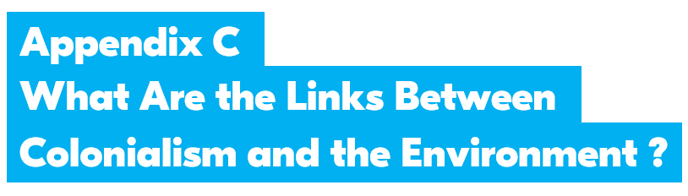

LESSON 2 - Colonialism and Fossil Fuels

Nigeria Research Sheet
Facts about Nigeria and Oil
- from Climate Museum UK

Starting in the 1600s, Europeans traded with and enslaved Nigerian peoples, and harmed their lands to exploit resources such as gold and cotton.

A British colony was established after the invasion of Lagos in 1851.

In 1960, independence from Britain was achieved but civil wars and military governments prevented peace.

The UK & Dutch company Shell has been extracting petroleum (oil) from the Niger Delta since it was discovered in 1956, causing extreme environmental damage. In 2011 (The Guardian, 2011), Shell admitted responsibility for two major oil spills.

The Ogoni people have been protesting this environmental damage, and in 1995 nine of their people, led by Ken Saro-Wiwa, were executed for their activism.

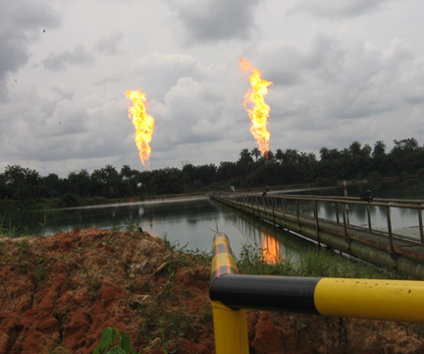
Gas flaring in the Niger Delta (Wikimedia Commons)
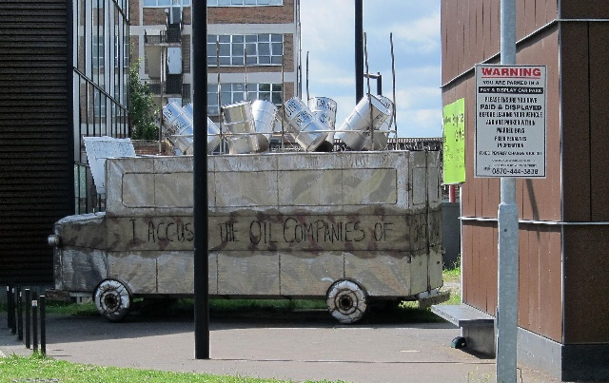

Ken Saro-Wiwa memorial bus (Wikimedia Commons)

Research the following online:
- The ancient Benin civilisation in Nigeria
- Nigeria’s resources and power
- Environmental issues in the Niger river delta
- The oil spill on the Niger Delta
- Amnesty International’s campaign about Shell and oil spills
- The Ogoni Nine people and their protests against Shell

Nigeria Weblinks

An overview of Nigeria in terms of resources and power from Encyclopaedia Britannica
https://www.britannica.com/place/Nigeria/Resources-and-power

Photographs of an oil spill on the Niger Delta from The Guardian newspaper
https://www.theguardian.com/environment/gallery/2011/aug/03/shell-oil-spills-niger-delta-in-pictures

Photographer Robin Hinsch’s photo essay about Nigeria and oil from The Guardian newspaper
https://www.theguardian.com/environment/2019/oct/18/wahala-trouble-in-the-niger-delta-photo-essay

Amnesty International’s campaign about Shell failing to clean up oil spills https://www.amnesty.org.uk/press-releases/nigeria-shell-still-failing-clean-pollution-niger-delta

Article about an artistic memorial in solidarity with the Ogoni Nine from The Guardian newspaper
https://www.theguardian.com/environment/2015/nov/05/ken-saro-wiwa-memorial-art-bus-denied-entry-to-nigeria

Article about three powerful moments in black environmental activism, including the Ogoni people’s fight against environmental damage in their land https://www.greenpeace.org.uk/news/three-powerful-moments-in-black-environmental-activism/

About 3 young black climate activists, including Oladosu Adenike in Nigeria who works as a country ambassador for the African Youth Climate Hub https://www.greenpeace.org.uk/news/black-history-month-young-climate-activists-in-africa/

Colonialism and Fossil Fuels

What impact has colonialism had on Nigeria?

Record your notes below.

- Why were the coastal areas of Nigeria so interesting to European colonisers?

- What peoples have lived in the area now called Nigeria? How have they been affected by colonisation?

- Where in Nigeria has oil been extracted? Who was involved? And where has it been exported to? Have other fossil fuels been extracted in Nigeria?

- What impact did oil extraction have on the local people and the environment?

- How and why have Nigerian people resisted and protested?

