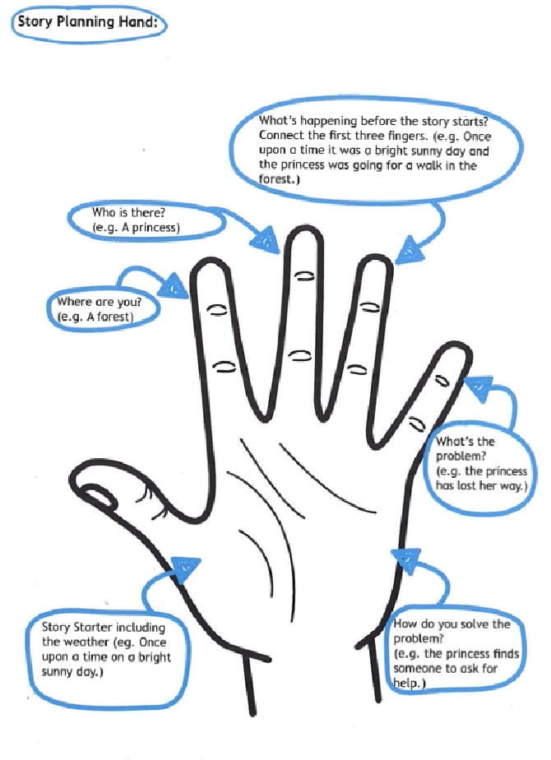

Prompt cups for EY classes or SEND schools
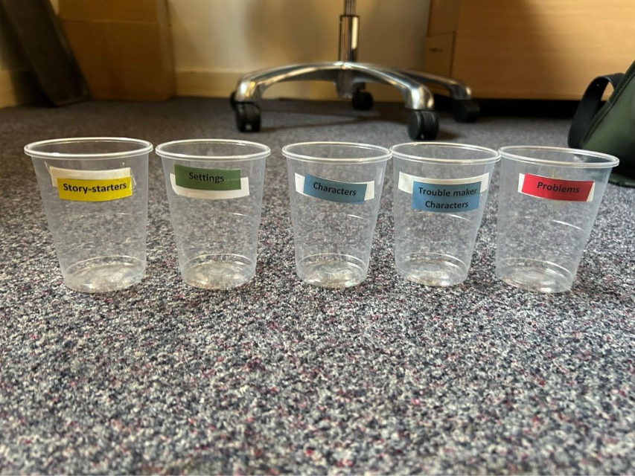

To print and cut out:

Story-Starters
Once upon a time on a windy day…
It was a beautiful cosy autumn day…
This day was just like any other day…
A long long time ago…
It was night time and everyone had gone to sleep…

Settings
a playground
an enchanted forest
a school
a very high mountain
a planet far far away

Characters
Little Red Riding Hood
Cinderella
a child called James
The Gruffalo
Hansel and Gretel

Trouble Maker Characters
The Witch of the West
The big bad Wolf
Cinderella’s Stepmother

Problems
The main character is hungry.
A big storm arises and it starts to rain heavily.
The Queen has lost her diamond ring and has asked anyone in the Kingdom to help.
All books have disappeared.
The main character is lost.

