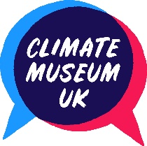

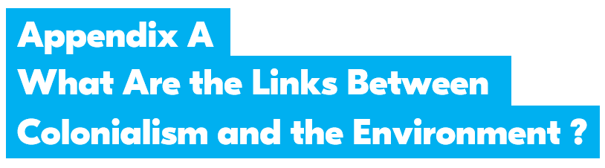

LESSON 1 - Wondering about Jamaica

Jamaica Enquiry Cards

1 - Jamaica’s People

Fact: Jamaica has a population of 2.9 million (in 2018) and two major languages – English (used by the government, media and in education) and Jamaican Patois (the primary spoken language).

Question: Why is English the main language used for public life in Jamaica?

See this portrait of an African Jamaican, Francis Williams. He was the son of a freed slave who became rich by profiting from slaves himself. Francis was a writer, lawyer and teacher, who wrote in English and Latin.

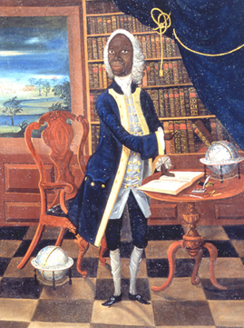
See this digital tour of the portrait of Francis Williams:
https://www.vam.ac.uk/articles/francis-williams-a-portrait-of-a-writer

Time to go further?
See this document in the National Archives about the decision of the Jamaican people to be independent from Britain in 1961:
http://filestore.nationalarchives.gov.uk/pdfs/small/cab-129-106-cp-142.pdf

Portrait of Francis Williams, artist unknown, oil on canvas,
circa 1745 from the V&A Museum (Wikimedia Commons)

2 - Jamaica’s Geography

Fact: Jamaica is 11,000 square kilometres and located to the West of Haiti.

Question: What are the key features of Jamaica’s physical geography and how did colonialists adapt to them?

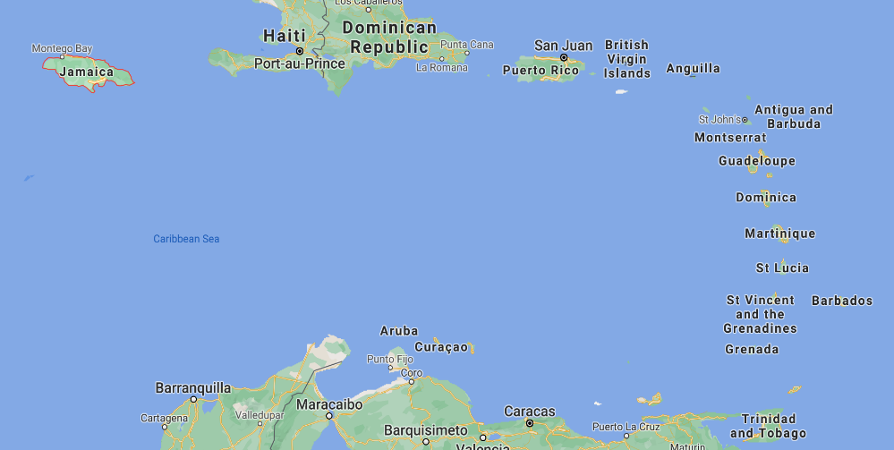

Find a map of Jamaica online e.g. http://ontheworldmap.com/jamaica/. What can you tell from the place names? What do you notice about the landscape?

Time to go further? Look at Google Maps of the Caribbean and see what you can find out about Jamaica and its links to neighbouring countries.

Screenshot from Google Maps

3 - Jamaica as a Colony

Fact: Jamaica was a British colony for 400 years.

Question: What impact did the British have on the island, its people, land and natural resources?

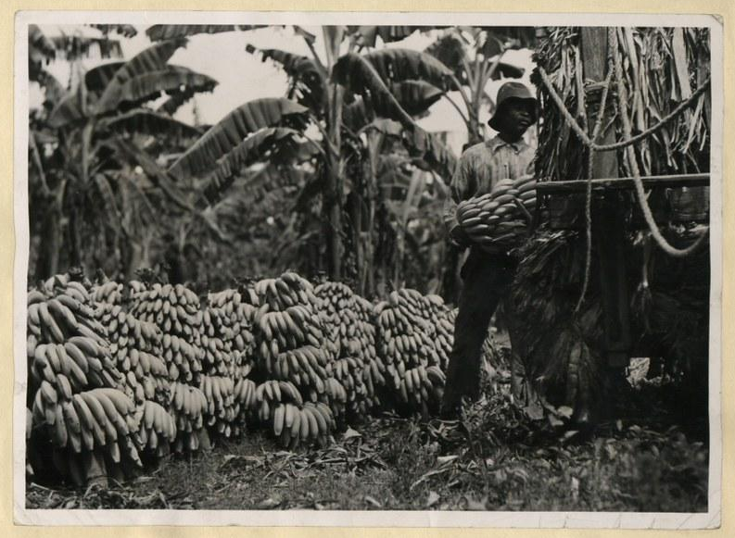

To help answer this, look at this photograph and others in the National Archives collection online using the link below.

Think about: What does the photographer choose to show? How has the land been changed?

Jamaican images from the Colonial Office Photographic Library, uploaded to celebrate 50 years of Jamaican Independence:
https://www.flickr.com/photos/nationalarchives/sets/72157630743140716/

Time to go further? Here’s another colonial document held in the National Archives: Memo from the Secretary of State for the Colonies about the state of the sugar trade, 10 February 1930

What was the crisis? Why did it matter?

The National Archives UK (Flickr)

4 - Slavery and Jamaica
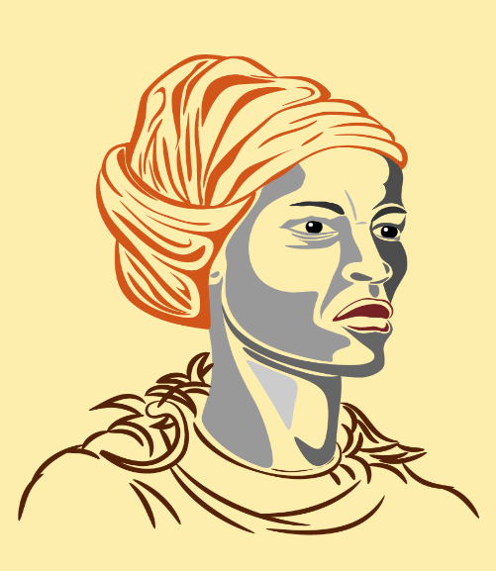

Fact: African people were enslaved and transported to islands like Jamaica to work as slaves for the colonial plantation owners.

Question: How did slaves resist and rebel?

Find out about Queen Nanny, the leader of the Maroons, the slave rebels living in forests and mountains of Jamaica.

Impression of Queen Nanny (Public Domain Vectors)

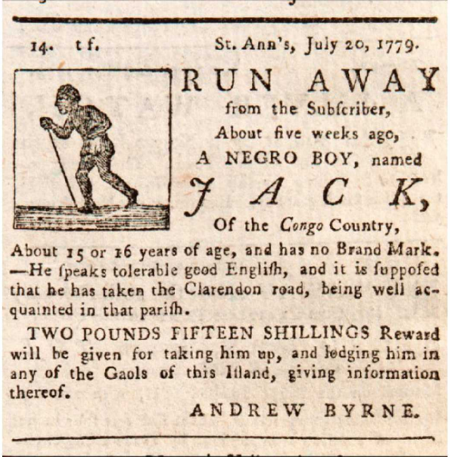

Time to go further? Look at this advert to catch the runaway slave, Jack.
Do you think escaping was a good way to rebel?

More information:
https://www.rgs.org/schools/teaching-resources/journeys-caribbean-stories/
200 years of campaigning against slavery:
https://www.antislavery.org/wp-content/uploads/2017/01/18072007.pdf

The Jamaica Mercury & Kingston Weekly Advertiser' Vol. 1 No. 32, Sat 27 Nov–Sat 4 Dec 1779 (MGS/45) (National Maritime Museum)
5 - Jamaica: A Place of Mining

Fact: Jamaica has been mined for bauxite, which is used to make aluminium.

Question: What impact has Bauxite mining had on Jamaica’s landscape?

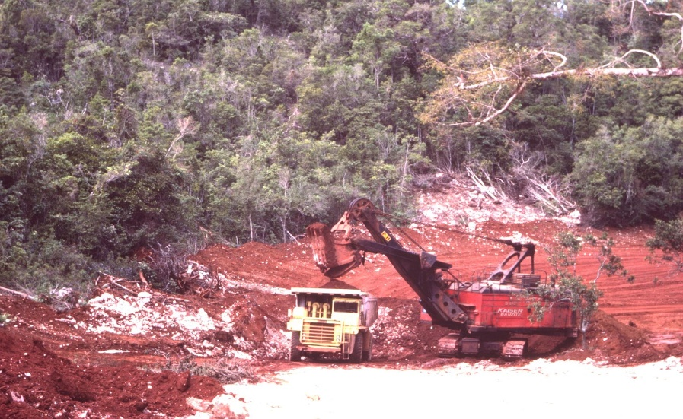

Search to find out how Jamaicans are trying to protect their environment from bauxite mining. What are their arguments?

Time to go further? Find out what else is being mined in Jamaica. Why is this industry expanding?

Bauxite mining in central Jamaica (Wikimedia Commons)

6 - Climate Change in Jamaica

Fact: Jamaica is vulnerable to the impacts of climate change such as worse hurricanes and floods.

Question: What evidence is there that hurricanes affecting Jamaica have grown worse?

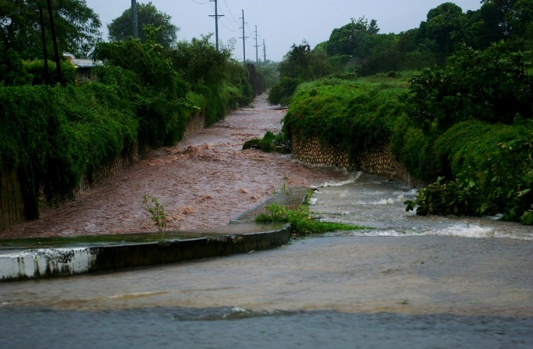

Look at a list of hurricanes in Jamaica. What patterns can you detect?

Time to go further? Why do you think climate change makes hurricanes and other kinds of storms worse?

A flooded road in Kingston during Hurricane Dean (Wikimedia Commons)

7- Jamaica: A Biodiversity Paradise

Fact: Jamaica’s habitats support over 900 plant species that are found nowhere else on Earth, and several endangered wildlife species.

Question: In what ways did Jamaica’s biodiversity change when coffee, bananas and sugar were planted on a large scale?

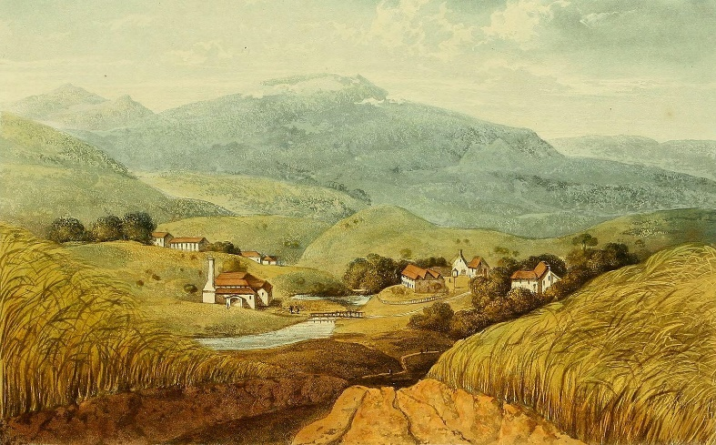
Discuss the impact it must have had, then search to see what evidence you can find.

Time to go further? Do you know of any animals or plants that are native to Jamaica? What would you expect to find there? Why? Search to find out.

A Picturesque Tour of the Island of Jamaica by James Hakewill, (1875) (Wikimedia Commons)

8 - Jamaica and Oil Extraction

Fact: Oil and gas are extracted from beneath the seabed around Jamaica.

Question: Why does Jamaica support the oil and gas industry?

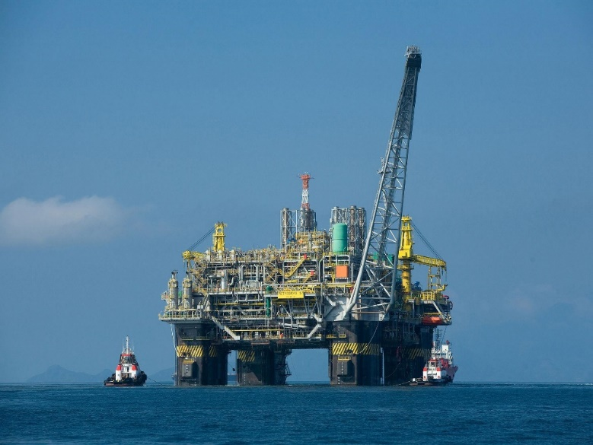
Petrojam is a fossil fuel company owned by the Jamaican government. It produces 35,000 barrels of oil a day. The UK firm United Oil & Gas has a licence to drill in Jamaica. Why might the Jamaican Government support this, even though fossil fuels have a dangerous impact on the climate?

Time to go further? What are some different types of renewable energy and where could they be located in and around Jamaica?

An offshore oil rig (Wikimedia Commons)

