SEND: SLD

Teaching
for Creativity Taster Cards
Quick challenges to practise creative habits

The Five Creative Habits of Mind
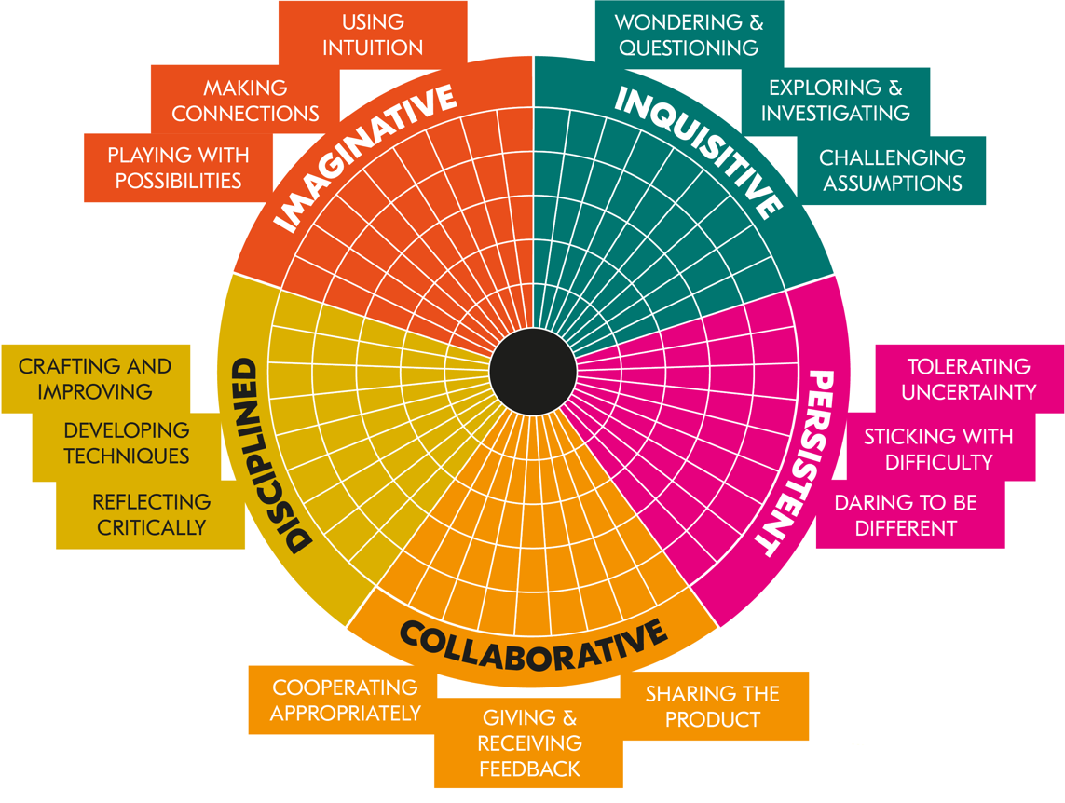
Developed by Prof Bill Lucas and colleagues at the University of Winchester

A New Direction, like many others, believes that creativity can be taught, and we want to support schools and teachers to feel equipped to do just this.

The pedagogies underpinning our Teaching for Creativity work come from the five Creative Habits of Mind – a concept developed from decades of research by Bill Lucas and colleagues which has now been widely adopted into learning policies across the globe. The Creative Habits of Mind are a great tool for tracking the development of your students’ creativity.

To find out more, visit: anewdirection.org.uk/teaching-for-creativity

How to use these cards
These activities have been designed for autism-specific SEND settings who work with students with a range of complex sensory and
communicative needs. Although the activities are aimed towards pupils with SLD (severe learning difficulties), they could potentially also be adapted for pupils with PMLD (profound and multiple learning disabilities) and MLD (moderate learning difficulties).

The activities work across different subjects and can be delivered as short 15 minute sessions or longer depending on the needs of your students. The reflection questions can either be posed to students or
used by teachers to support their assessment for learning as they observe students.

We know that teachers in these settings will know how best to adapt activities for their students, but we hope these cards help you to develop and use pedagogies for the Five Creative Habits with your students.

Sharing Stories

Sensory
worlds

- Create a class story together, giving students a choice between two options for the scenes, characters and actions in the story
- Incorporate students’ special interests for each of the choices, ideally displaying images of each
E.g. You might start off trapped in either a maze or a pizza restaurant with weather outside that is either raining or windy, and then escape fast or slowly thank to the help of…
- Create a box filled with props for each decision that needs to be made. For example:
  - A parachute for everyone to start sat under
  - A microphone to make sounds
  - Spray bottles, fans and torches for the weather
  - A drum to help represent the speed of movement
  - Oyster cards, red fabric and steering wheels for transport
  - Any other special interest toys
- Run through the story twice, asking students in turn to choose and make decisions in the story when it is someone else’s special interest in the choice and not their own
- Add extra moments in the story based on pupil responses, allowing them to shape the story

Reflection: Did you choose someone else’s special interest or only your own? Did you enjoy listening to other people’s ideas?

Go Further: Note down pupil preferences and incorporate them into new stories.
- Use sensory props to create a world students can explore. For example:
  - Under the sea
  - Jungle
  - Transport
  - Desert
- Allow pupils to explore the worlds at their own pace, with staff facilitating ‘events’ that happen to all pupils
E.g. a big wave or sandstorm that washes over all of them, or draw everyone’s attention to a specific animal, train etc.
- As the session progresses, note how the students’ curiosity develops by watching them interacting with different objects and experiences
- Eventually, you may begin to see students initiate interactions they enjoy with staff members or peers

Reflection: Which part of the world do you want to know more about/experience/look at again?

Go Further: Don’t be afraid to repeat these sessions. Notice what pupils are interacting with and create new ‘events’ in response to this.

Collaborative: Co-operating Appropriately
This activity supports students in turn-taking and listening to others’ ideas, encouraging them to contribute positively to group work. This activity also supports being persistent and imaginative.

Inquisitive: Exploring and Investigating
This exercise encourages pupils to explore and investigate a creative, imaginary world through sensory play. This activity also supports being collaborative and imaginative.

Treasure Chest

Group Photographs

- Create multiple boxes with hand holes in them so that pupils can reach inside without seeing what is in them
- Fill each box with different sensory experiences e.g. wet flannels, soft fur, heated beanbag, cold ice pack etc.
- Verbally comment on what they are feeling through descriptive language or, if appropriate, ask them what they feel, building up to see if they can guess what the object might be
- After they have experienced the objects without looking at them, let the students then explore the objects outside of the boxes so they can see them and touch them again

Reflection: How did you feel exploring the objects inside the boxes without being able to see them or knowing what they were? Was it different to when you could see the objects?

Go Further: You could use this as an introduction to a topic and use objects connected to the theme. You can have different boxes that contain objects relating to the weather that day, the cultural celebrations that month etc.
- Lay out a range of unusual costumes and ask students to choose one
- Encourage students to embody characters related to their costume. For example, you could ask them to move around the room in the style of their character – will they move carefully and slowly or excitedly and fast? If they have props, encourage them to act out with them if appropriate
- Gather everyone together and take a picture of everyone in their costumes
- If appropriate, give instructions to jump, put hands up, wave at the camera or pull a funny face – reminding them that they are still the character! What do they think their character would do?
- Take a few different pictures then look at them as a group on a big screen. Comment on each student’s choice of costume and pose, explaining what character you think they are and how you know

Reflection: How did it feel to be another character?

Go Further: If you are working with a story, you could use props and costumes related to the specific characters in the story. You could show these pictures at the beginning of future lessons as a recap of previous learning – teachers can talk through each character and costume choice then praise pupils for their choices.

Persistence: Tolerating Uncertainty
By not knowing what they will feel inside the box students are introduced to the idea of uncertain ideas. This activity also supports being inquisitive and imaginative.

Imaginative: Playing with Possibilities
The exercise encourages students to experiment with wearing expressive costume pieces and playfully explore characters associated with them. This activity also supports being collaborative.

Masking Reflecting

- Lay out a range of expressive masks (trestle masks work best)
- Get pupils to choose and wear a mask one at a time
- They can look at themselves in the mirror and show their choice to the rest of the group
- Comment on what expression is shown on the mask and encourage the students to physically embody the expression, for example if the face is sad, what would their body be doing?
- If appropriate, you could ask students to comment on what expression or emotion they see. Praise their responses but also suggest other interpretations

Reflection: How did you know what the emotion was?

Go Further: Use these masks while reading stories that involve emotional responses or in any session which discuss emotions.
- Film or take photos of students taking part in an activity
- Use the video footage or photographs to reflect on work they have done, showing it to the students
- Comment on what the pupils are doing in the footage, celebrate their achievements and highlight anything specific
- Recreate activities they particularly enjoyed or did well immediately after showing them the footage

Reflection: What did you enjoy the most and why? What are you proud of and why?

Go Further: Observe students’ responses when watching the footage, are they proud or interested? Capture footage of them engaging in a contrasting activity and allow them to view both while commenting on the differences.

Imaginative: Making Connections
By looking for connections between masks and expression/emotion, students link to their existing knowledge and experiment with physical interpretations. This activity also supports being inquisitive.

Disciplined: Crafting and Improving
Repetition of activities after experiencing success supports a willingness to put in more hard work and encourages students to improve deliberately.

We hope you enjoy exploring the activities in these Taster Cards!

To find out more about our Teaching for Creativity work & browse more free resources, visit:
anewdirection.org.uk/ teaching-for-creativity
We’d also love to hear your thoughts! Drop us an email or get involved on social media:
#TeachingforCreativity schools@anewdirection.org.uk
@A_New_Direction @anewdirection_ldn

Resource written by Elise Roberts

