EYFS

Teaching
for Creativity Taster Cards
Quick challenges to practise creative habits

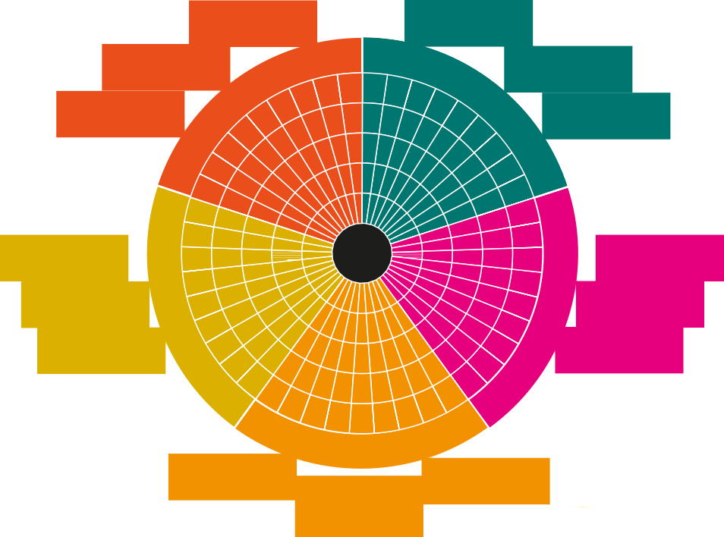The Five Creative Habits of Mind
USING INTUITION
WONDERING & QUESTIONING
MAKING EXPLORING &
CONNECTIONS INVESTIGATING
PLAYING WITH CHALLENGING
POSSIBILITIES ASSUMPTIONS
CRAFTING AND IMPROVING
DEVELOPING TECHNIQUES
REFLECTING CRITICALLY
TOLERATING UNCERTAINTY
STICKING WITH DIFFICULTY
DARING TO BE DIFFERENT
COOPERATING APPROPRIATELY
O
GIVING & RECEIVING FEEDBACK
SHARING THE PRODUCT
P
D

A New Direction, like many others, believes that creativity can be taught, and we want to support schools and teachers to feel equipped to do just this.

The pedagogies underpinning our Teaching for Creativity work come from the five Creative Habits of Mind – a concept developed from decades of research by Bill Lucas and colleagues which has now been widely adopted into learning policies across the globe. The Creative Habits of Mind are a great tool for tracking the development of your students’ creativity.

To find out more, visit: anewdirection.org.uk/teaching-for-creativity

How to use these cards
These cards have been designed for Early Years and Foundation Stage groups and settings.
They could work within different subjects and can be short 15-minute sessions or longer depending on the needs of your children.
The reflection questions are aimed at educators to help you reflect on children’s actions and assess their progress through observation.
We know that educators in these settings will know how best to adapt activities for their students, but we hope these cards help you to think about how to deliberately use pedagogies for the 5 creative habits in activities with your students.
Some of the activities are aimed at under 3s
Und3er
Others are more suited to 3 to
5-year-olds

3-5

Conducting with Teddy

Under
3

Heritage Bags

Under
3

- Give each child a simple shaker e.g. egg shakers, hand bells, maracas or homemade shakers.

- Introduce a familiar teddy or puppet and explain that ‘Teddy’ loves to dance but needs to have some upbeat dance music to dance along to.

- Move the toy so it dances and encourage the children to make music with the shakers. Model that if Teddy stops dancing, they stop shaking.

- After you have done this a few times, Teddy can tell you that he wants to dance with someone else – pass the Teddy to a child to have a go a leading.

- Continue, giving children choices about who to pass the Teddy to so they can take a turn to lead.

Reflection: Were the children able to support and listen to each other?

Go Further: Vary the tempo Teddy moves at to affect the music. Try physical conducting of jumping in and out of a hoop or start and stop songs with the body / instruments.
- Ask family to donate special items that are important to them and their child to create a heritage bag. E.g. family pictures, heirlooms, a scent of a familiar family member’s cologne on a piece of cloth, drawing or writing materials, menus from the places they have eaten at, items of clothing, flags, cultural artefacts etc.

- Spend time 1:1 with children and their adults, or in small group sessions, exploring the items in their bags together.

- Model lots of descriptive language and allow children to touch and speak about the bags and their items.

- Allow space to be curious yourself about the items and about finding new ways to tell stories.

Go Further: Scribe down what is said by child and adult and turn it into stories, dances, or songs.

Reflection: Do the children respond to the items / show an interest in them? Do they ask any questions about them or show a preference for any? If in a group session, do children show interest in other children’s objects?

Collaborative: Children work as a group both through playing together, following instructions and honing their listening and watching. It supports them to take turns and make choices.
Inquisitive: This activity develops curiosity about identity and community and encourages children’s confidence around talking about and sharing things about themselves.

Tape Time
Und3er

Story Telling with Objects
3-5

- Introduce a container of objects that evoke awe and spark conversation. E.g. maps, postcards, keys, telescopes, shells, flags, jewellery, gadgets.

- Ask children to select an object and introduce it to the group
i.e. what they like about it / what they think it is. Encourage abstract / different uses of the objects.
- Where do they think the items came from?
- Who did they belong to?
- How were the objects used?

- Support children to tell a story incorporating their descriptions into imaginary scenarios. You could write it as a group on the board. E.g. if a child were to imagine a river that is blocked, you might ask which one of the objects might help them to get across and how?

- Retell the whole story back with the children joining in acting out and animating their objects.

Reflection: Were any objects more helpful in sparking their imagination? Were the children able to think of different contexts to use the objects, did any surprise you?

Go Further: Create a provocation box of items that children can discover and mix and match items. You may want to link a box to a specific story character or historical figure in a loose way.
- Introduce non-marking tape to floors and surfaces in your setting to create a range of different physical environments for young children to explore. E.g. road maps on the floor and cities on the wall creating a city scene, a tape maze, arrows that go through an obstacle course or suggest a direction of travel, a spiral, a start and finish line.

- Observe how children physically interact with these environments and set small challenges, for example:
- Something on one side of the tunnel that they need to collect or a puzzle to change one block/piece at a time
- Giving cars or vehicles that can move through the taped roads
- An object to collect in the middle of your maze
- Paper planes to throw across from the start and finish line

3. Create movement invitations and see how children explore the spaces you have created.

Go Further: What happens if you give children some rolls of tape to create an environment in a set area? Create different challenges or add to marked areas to extend children.

Reflection: Do they persevere or give up easily?

Persistent: Some children will create their own physical challenges within these defined spaces and will demonstrate persistence and trying different things out or do an activity until they have accomplished or mastered it.

Imaginative - Playing with Possibilities:
Through playful experimentation, children explore possibilities and look
for connections, linking their existing knowledge and understanding of the world.

Group Story Score
3-5
- Spread a large roll of paper across the floor that children can sit around (e.g. wallpaper roll). You will need marker pens and a familiar story that the children know well.

- Draw around the feet of three children while standing on the paper, facing the same way.

- As a group, choose three memorable scenes from a story (sequential or not) and ask children to use a sound/action/ phrase to match it.

- Draw a symbol for the sound next to each feet drawing.
E.g. a wiggly line to represent the sound of wind through the grass.

5. Invite different children one at a time to ‘conduct’ by jumping on the feet while the rest of the group responds with the sounds that have been selected to create a performance.

Reflection: Did children listen to each other? How did they respond to each other’s suggestions? Did any show preference for particular roles? Were they able to take turns?

Go Further: Offer a selection of instruments to support the sounds. Add more scenes from the story, change tempo, or volume by jumping or tip toe. You could introduce some composers and conductors e.g. Shirley Thompson.

Windows
3-5

Collaborative - Co-operating Appropriately:
- Provide a selection of ‘window frames’ either cardboard, old picture frames, photo frames etc.

- Encourage the children to hold their frame in different positions focusing on different parts of the room. What do you notice or observe through your window? Can you find specific things through your window? E.g. something very small, something blue, something man made, something that is part of the natural world, a letter, a number.

- Provide children with cameras or drawing materials and ask them to record their favourite view through their window
– what do they like about it? You could also use natural materials to create scenes within your windows or take photographs.
- Do you have any questions about what you see?
- Does it remind you of anything else?
- What was the most interesting thing you noticed?

Reflection: Do children display any dominant patterns/themes?
E.g. did they focus on faces/feet, or on tiny details/patterns?

Go Further: Introduce the wordless book Windows by Jeannie Baker and explore how the view outside our windows changes over time. Use time-lapse photography through a window to explore how the environment changes and our impact.
Children work as a group to make decisions, listening to each other’s suggestions and turn-taking to achieve a small performance.

Inquisitive - Wondering & Questioning:
This supports students to think of different kinds of questions, provokes curiosity about a topic and starts to develop deeper discussions.
3-5
Marshmallow Spaghetti Towers
Everybody on the Floor

3-5
- Using a slippery floor, have children lie on a paper plate/ piece of paper/fabric. Can children move across the floor while keeping the plate or other object attached to their tummy? Use masking tape on the floor to demark a start or finish.

- Evolve the activity by creating a treasure hunt along the way, collecting objects or arranging obstacles to move around or underneath. Children could try it on a different part of their body, for example on their side, sitting down using feet to push along.

- Some children may find the crawling activities challenging or frustrating but with gentle encouragement and observing others, persistence can be modelled.

Reflection: Observe how children evolve the game and create their own rules. Do they persevere or give up easily? Do they have difficulty in a more physical task or does a child who is not verbally communicating excel in a physical challenge?

Go Further: Use bubbles and blow them above the children lying down, asking them to pop them with their toes. Play slow, calm music and pause in between bubble blows to breathe or count breaths.
- You will need a bowl of marshmallows and different lengths of long spaghetti. Model how to join different lengths of spaghetti to marshmallows, creating different types of structures.

- Set different engineering challenges. E.g. Can you make a 3D shape? Can you make a shape that balances and holds some weight upon it? Who can make the tallest tower?

- Give some initial suggestions of how to stabilise the shapes or towers that children make (e.g. using triangles).

- Ask children what they like about the structure, or how they could improve them. They could work with a partner if needed.

Reflection: If something doesn’t work, do they try different things, are they able to see why? Does the activity get easier the more they try/experiment/repeat fine motor skills?

Go Further: You could introduce straws or big blocks. Find out about some of London’s architecture by displaying images e.g. by architect Zara Hadid.

Persistent - Sticking with Difficulty:
Children are encouraged to use their bodies to overcome a challenge. These types of movement activities support hand-eye coordination and body/spatial awareness, relieve body stress and support greater levels of self-regulation.

Disciplined – Crafting and Improving:
This activity requires patience and the ability to analyse failures. Some children will find that the spaghetti breaks easily while others will find their towers collapsing so reflection and refining is a continuous loop throughout the activity.

We hope you enjoy exploring the activities in these Taster Cards!

To find out more about our Teaching for Creativity work & browse more free resources, visit:

anewdirection.org.uk/ teaching-for-creativity

We’d also love to hear your thoughts! Drop us an email or get involved on social media:

#TeachingforCreativity @anewdirection.org.uk
@A_New_Direction @anewdirection_ldn

Resource writer:
Angeline Conaghan from Groundswell Arts

