MLD
Teaching
for Creativity Taster Cards
Quick challenges to practise creative habits

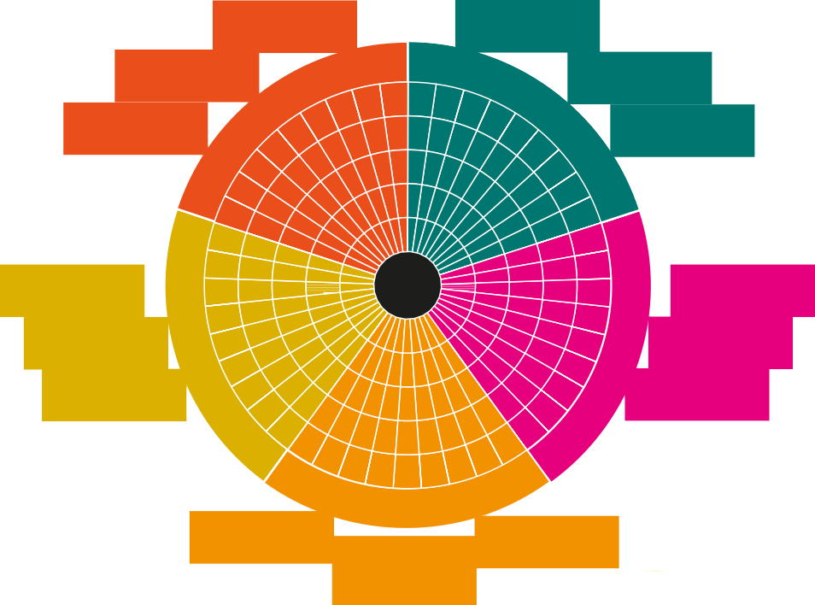The Five Creative Habits of Mind
USING INTUITION
WONDERING & QUESTIONING
MAKING EXPLORING &
CONNECTIONS INVESTIGATING
PLAYING WITH CHALLENGING
POSSIBILITIES ASSUMPTIONS
CRAFTING AND IMPROVING
DEVELOPING TECHNIQUES
REFLECTING CRITICALLY
TOLERATING UNCERTAINTY
STICKING WITH DIFFICULTY
DARING TO BE DIFFERENT
COOPERATING APPROPRIATELY
O
GIVING & RECEIVING FEEDBACK
SHARING THE PRODUCT
P
D

A New Direction, like many others, believes that creativity can be taught, and we want to support schools and teachers to feel equipped to do just this.

The pedagogies underpinning our Teaching for Creativity work come from the five Creative Habits of Mind – a concept developed from decades of research by Bill Lucas and colleagues which has now been widely adopted into learning policies across the globe. The Creative Habits of Mind are a great tool for tracking the development of your students’ creativity.

To find out more, visit: anewdirection.org.uk/teaching-for-creativity

How to use these cards
These activities have been created by Corali Dance Company for SEND settings, specifically for students with MLD (moderate learning difficulties), and focus on using dance, drama, and movement.
Each card is aimed at being a short 15-minute session, but it could be adapted to be longer depending on the needs of your students. All of these activities can be adapted for use in large spaces such as the hall or outside.
They could potentially be adapted for pupils with SLD (severe learning difficulties), and PMLD (profound and multiple learning disabilities).
We know that teachers in these settings will know how best to adapt activities for their students, but we hope these cards help you to think about how to deliberately use pedagogies for the 5 creative habits in activities with your students.
They could be suitable for small group work with students in mainstream settings too, and many would be suitable for work in drama with EYFS and Key Stage 1 pupils.

Together collage
Collaborative: Students share ideas and work together to create a picture, then support each other to make and develop movement, both individually and then as a group. They are given an opportunity to share the product.
- In groups of three, students each choose three strips of coloured paper.

- On one piece of large paper per group, students choose together where to put the strips to make a collage of their nine strips of paper.

- Next, students choose one line each and make a movement representing their chosen line, using their body.

- Ask students to show which line it was and why they made that shape.

- Can students combine their movements together? How does their line connect to others? When does it cross or follow on from another? Can they show this through their movements to create a dance based on the collage?

Reflection: What is it like to do this together? Did you help each other? How? Do you think it helped you find new ways to move?

Go Further: Students could choose another line on the collage and make the shape very different from the first one they made i.e.
“If you made the first line with your arm, make this one with your foot.” Encourage students to help each other make different sorts of movement to the lines and find different ways to connect.

Exploring objects through dance

Inquisitive: Students look at everyday objects are encouraged to be curious about them, thinking about qualities other than function. They move on to seeing objects differently, exploring them through movement.
- Put a bag of everyday objects in the middle of the space e.g. rolling pin, spoon, pillow, water bottle etc.

- Pick out an object and explore/ discuss the objects with the following questions:
  - How does it move
  - What sound does it make?
  - What is it’s shape?
  - What are the qualities? e.g. is it smooth, rough, spiky?

- Ask each student to create a movement as an answer for each of the questions. You could do this as a whole group at first, asking for a suggestion from each student for each movement.

- Practice the order of movements to make a sequence.

- You can repeat with another object or let the students each choose different objects.

Reflections: What other objects could we use to create movement? Did you look at the object differently? What object gave you the most inspiration?

Go Further: Find more objects and link all your movements together. Play around with the order of movements. Try using different body parts, for example using your arms, fingers, hips or feet.

Leaders
Persistent – Daring to be Different:
In this activity, students practice coming up with unique movements and leading a group. Focus is essential in being aware of change, space and bodies around one another. They are also tolerating uncertainty – not knowing what movement will come next!
- Put on some music – this can be any genre but something upbeat and easy to dance to would work best.

- Everyone makes a line and the person at the front starts dancing. Everyone else copies their dance. They should move around the room if the space is big enough, so the line is traveling as they dance. You could do this in a circle instead.

- After 1 minute, a timer goes off and the leader changes by moving to the back of the line so there is a new person at the front.

- The person at the front makes a different sort of movement and again, everyone copies.

- What did it feel like to lead? Did you like it when the timer went off? How easy was it to make a different movement to other people?

Reflection: What did it feel like to lead? Did you like it when the timer went off? How easy was it to make a different movement to other people?

Go Further: See if the group can change the leader themselves without a timer, and in any order. Add in development through changes in levels, speeds and dynamics. Try in smaller groups and start to fix movements you would like to share with the rest of the group.

Magazine Dancer
- Provide picture books and magazines and ask students to each choose a picture.

- Using a small window (a square cut out of a paper or card) to frame part of the picture, students choose a detail to draw on their blank pieces of paper, such as a shape or a line.

- They repeat this, drawing the same detail until they have four drawings together on the paper.

- Students then make up a movement for each of their four drawings, using different body parts for each one.

- Ask students to rehearse their movements, using the drawings as a prompt sheer to help them remember the order and the movements they have made up.

- Students can perform their dances to each other in pairs, groups or as a class.

- Can students rehearse the dance so they can remember it without the drawing prompts?

Reflection: How did it feel to choose a shape to frame and copy? What did it feel like to make a movement with your body based on your drawing? Did the pictures help you remember the movement? Which movement and drawing did you enjoy the most?

Go Further: Try doing the dance to different sorts of music. Put the drawings in a different order and make a new dance. Swap drawings with a friend and try out their dance!

Disciplined – Developing Techniques:
By developing an understanding of the relationship between image and movement, students practice repetition and rehearsal of movements.
If students perform their dances, they will also practice collaboration: sharing the product.

Character surprise
- Each student has a piece of paper and pencil.

- Put on some music, tell students to close their eyes and draw on the paper using only the music to inspire their pencil movement.

- Ask them to choose a shape to be a character or strange creature and cut it out.

- Now, they think about how their character might move, sound, live or eat.

- They try being their character by moving and making its sound, interacting with other characters in the room. You could change scenarios to see how the characters react e.g. there is a thunderstorm, or an ice cream van comes to town.

- Students then find a partner and tell a story about their character to them.

Reflection: How did it feel to draw without being able to see the paper? Were you surprised by what you created? How did you know what character would move and sound like?

Go Further: Learn the characteristics of your partner’s character. How does it feel and change in your own body? You could write down the stories or perform some of the stories in groups.

Mirror Me
Collaborative – Co-operating Appropriately
Students practice working together, exploring how it feels to be the leader and to go along with some else’s ideas.
- Students sit opposite a partner each with paper and a pencil.

- They choose who is going to be the leader and who is the follower.

- Put on some slow music (no vocals) and the leader responds to the music by drawing on the paper. The follower mirrors the movement of the pencil on their own paper.

- After a few minutes, place pencils down. Partners stand up facing each other and the leader now uses their arm like a pencil to move to the music and the follower mirrors the movement.

- Repeat by changing the follower to become the leader.

Reflection: Was it easy or hard to follow the leader? Would you like to try faster music? Did you prefer being the leader or the follower? Would you like to try in larger groups?

Go Further: Take this into a larger space and extend the movement to large, fast, as well as travelling across the space and levels, so the mirroring becomes more complex and becomes like a duet.
Imaginative – Playing with Possibilities:
In this activity, students use random images produced to the sounds of music to create a character, exploring how they behave, move and sound. Students can also practice collaboration by working with a partner.

Mirror Expressions
We hope you enjoy exploring the activities in these Taster Cards!

To find out more about our Teaching for Creativity work & browse more free resources, visit:
anewdirection.org.uk/ teaching-for-creativity

We’d also love to hear your thoughts! Drop us an email or get involved on social media:
#TeachingforCreativity @anewdirection.org.uk
@A_New_Direction @anewdirection_ldn

Resource written by Corali Dance Company:
Nicola Rayworth (Lead Associate), with Andrea Swainson (Engagement and Outreach Manager) and Bridget Chew (Associate Artistic Director).
- Provide students with an individual mirror.

- Students explore being close and far away from the mirror.

- Call out emotions to pull faces in the mirror, use the visual prompts if needed. Do a countdown for students to pull their favourite emotion.

- Next, set up character images around the room. Individually or in pairs, students visit the images and explore emotions in that ‘character’ using their mirror.

- After the students have explored a few characters, ask them to choose one. Students should then move around the room in that character, using their faces and their bodies. Start with emotions (but remind them to be the character not themselves!) and progress to other scenarios e.g. travelling down the road, waving hello, reading a book.

- Pause the students to be a freeze-framed in their characters, then choose one student to share their freeze-frame. Ask the rest of the class to guess which character they think they could be. Repeat this a few times.

Reflection: Which was your favourite character and why? Which emotion did you find difficult to express? Did the mirror make it easier or harder to practice acting emotions?

Go Further: What sounds could be made to match each emotion? Have two different emotions travel towards one another. Explore emotions further with picture cards or by drawing them.

Persistent – Tolerating Uncertainty:
Students start off by exploring emotions without knowing what comes next, and when asked to act out the character, they are not sure what emotion or scenario will be called out - they must think in the moment. Looking into the mirror and looking at yourself can also be difficult, so trying different facial expressions and remaining engaged practices sticking with difficulty.

