Brief – Easy Read
Cultural Ambassador Programme Leader

Role:
Cultural Ambassador Programme Leader (freelance)
Fee:
£12,600 (42 days at £300 per day)

Dates:
42 days between June 2024 to end of March 2025.
Every Thursday from September 2024 to March 2025 apart from during school holidays.

17th March 2025 to 21st March 2025 for the I Am Festival.
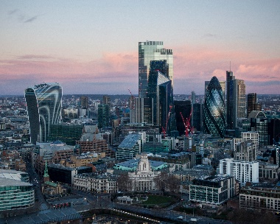 | The programme will take place in person at a location in London.  The exact location will be confirmed.
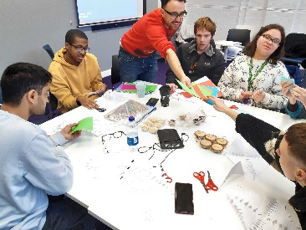 | The Cultural Ambassador Programme Leader will work with 10 Deaf, disabled and neurodivergent young people on a work experience programme.
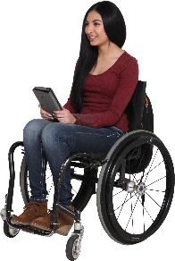 | We are interested in hearing from individuals who identify as disabled.
 | If you are successful in this role you will need to complete a Disclosure and Barring Check (DBS)
 | You must be eligible to work in the UK
 | This is a freelance role. You must be registered to pay your own taxes.
 | We are committed to breaking down barriers to employment and welcome conversations around how we can make this role more accessible for you.

About A New Direction
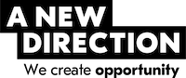 | A New Direction is a London-based non-profit organisation.
 | We generate opportunities for children and young people to unlock their creativity.
 | Our vision is for a world where all children and young people achieve their creative potential.
 | Our mission is to enhance the capacity of children and young people to own their creativity, shape culture and achieve their creative potential.
 | To do this we work with lots of different partners including schools, local authorities and cultural organisations and create opportunities for children from childhood, through school years and into employment.
An Easy Read version of our Values can be found on our website:

https://www.anewdirection.org.uk/about-us/our-values

About the Cultural Ambassador programme:
 | This is a work experience programme for 10 Deaf, disabled and neurodivergent young people.
 | It will take place over 22 weeks.
 | A New Direction delivers this programme in partnership with a charity called AFK. They provide education, training and work experience programmes for disabled young people.
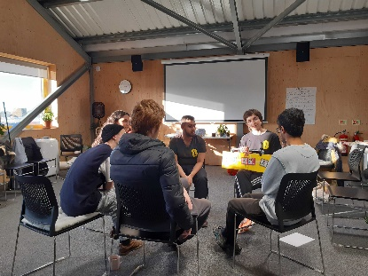 | The Cultural Ambassadors will learn more about the creative and cultural sector.
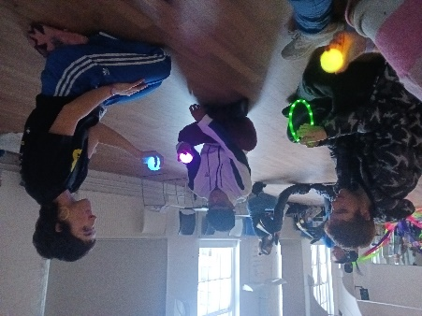 | They will work with artists and organisations.
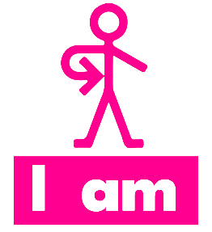 | They will plan and deliver a creative project as part of I Am Festival 2025.
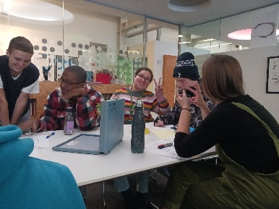 | They will develop their:  - Confidence  - Independence  - Teamworking skills  - Communication skills.
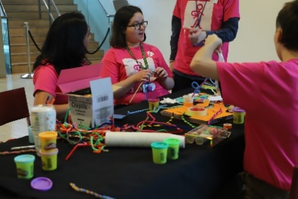 | They will train for roles that they will do during the I Am Festival week, including:  - Stewarding  - Welcome Desk support  - Workshop support  - Evaluation support

About the I Am Festival
 | The I Am Festival takes place every year.
 | 2025 is the 10-year anniversary of the I Am Festival.
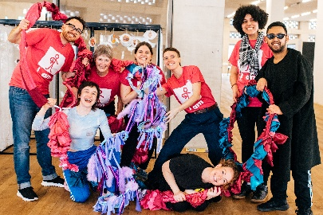 | The festival celebrates the creativity of Deaf, disabled and neurodivergent children and young people.
 | In 2024, the festival took place in 4 venues across London.
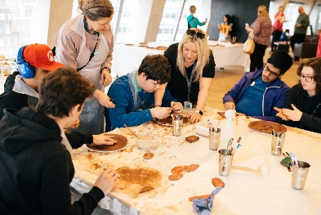 | Over 150 students from SEND settings came to experience the festival.
 | The Cultural Ambassadors planned and delivered an event called I’m Amazing, You’re Amazing.

About the Role
The Cultural Ambassador Programme Leader will:

 | Support the planning and shaping of the Cultural Ambassador programme.
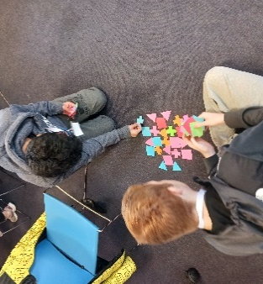 | Plan and deliver creative, accessible and inclusive weekly sessions.
 | Work with AFK, the I Am Programme Producer, the Programme Support and the wider A New Direction team to manage the shape of the Cultural Ambassador programme.
 | Creative a positive and collaborative environment for the group to work in.
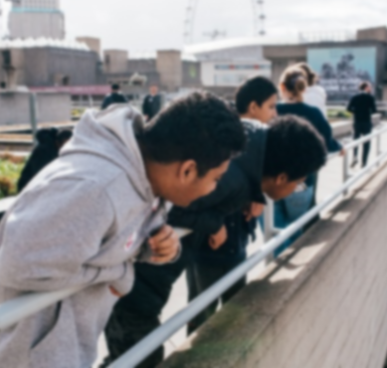 | Organise and accompany the Cultural Ambassadors on visits to cultural spaces.
 | Support organisations and artists to deliver accessible and relevant workshops for the young people.
 | Support the Cultural Ambassadors and Programme Producer to plan, budget, and deliver a creative project for the 2025 I Am Festival.
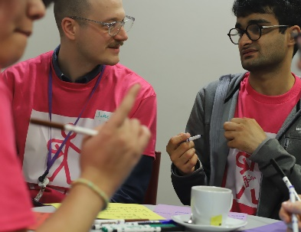 | Coordinate and support the Cultural Ambassadors during the I Am festival.
 | Support conversations around creative progression routes with cultural organisations, A New Direction, and AFK.
 | Support the Cultural Ambassadors to develop skills in communication, team working, and problem solving.
 | Support the Cultural Ambassadors to develop skills which they can take forward into the working world, depending on the needs and interests of the group.
 | Support the Cultural Ambassadors to develop knowledge of the cultural sector.
 | Support the Cultural Ambassadors to develop confidence in advocating for disabled young people.

Key Dates
Planning and meeting with A New Direction | From June 2024
Cultural Ambassadors work experience programme | September 2024 – March 2025 (excluding school holidays)  Weekly on Thursdays from 10am – 3pm  Exact location will be confirmed.
I Am Festival | Monday 17th March to Friday 21st March 2025.
Evaluation and celebration | During the week of 24th March 2025.

What are we looking for?
Skills
We are looking for someone who can demonstrate the following skills:

Ability to communicate and support Deaf, disabled and neurodivergent young adults.

Ability to work with and gain trust from young people from a wide range of backgrounds.

Ability to be flexible and adaptable to different working environments.

Ability to work independently.

Ability to meet deadlines and work with accuracy and attention to detail.

Knowledgeable about the arts and cultural sector and employment routes into these industries.

Ability to create accessible documents such as Easy Read (desirable)

Approach
We are looking for someone who:

 | Displays a strong empathy with the values and vision of A New Direction
 | Centres the voices and opinions of Deaf, disabled and neurodivergent young people.
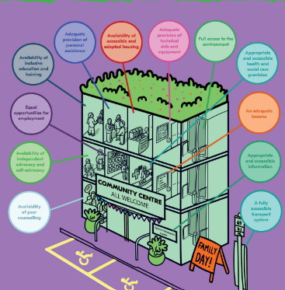 | Applies the Social Model of Disability to their work.
 | Is tactful, calm, and sensitive.
 | Is focused on outcomes and proactive in problem-solving.
 | Is trustful, honest and dependable.
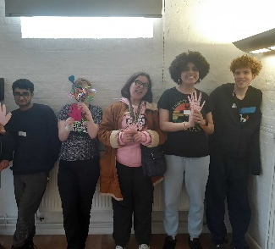 | Is committed to working in an environment which values and celebrates diversity.

Experience
Experience of working with Deaf, disabled and neurodivergent young people.

Experience supporting content production for events (desirable)

How to Apply

If you are interested in applying you can send us:

 | An Expression of Interest document no longer than 2 sides of A4
OR
A 5-minute video
OR
A 5-minute audio recording
 | In your Expression of Interest, you should include:
 | Your understanding of the brief and how your experience relates to the brief
 | How you would support the Cultural Ambassadors
 | An idea for a workshop that could be delivered as part of this programme, either by your or an organisation or artist.
 | Any access requirements that you would like us to be aware of.
 | Please send your Expression of Interest to schools@anewdirection.org.uk
 | If you would like to have a chat with us before submitting your application, you can email us at schools@anewdirection.org.uk
 | You can also call us on 020 7608 2132.
13 | The deadline for sending this is 5pm on Monday 13th May 2024.
 | Shortlisted applications will be invited to a short interview.
 | Interviews will be held on Tuesday 21st May and Thursday 23rd May.
 | If there is any additional support you may need to complete this application or fulfil this role, please let us know by calling 020 7608 2132 or emailing schools@anewdirection.org.uk.

