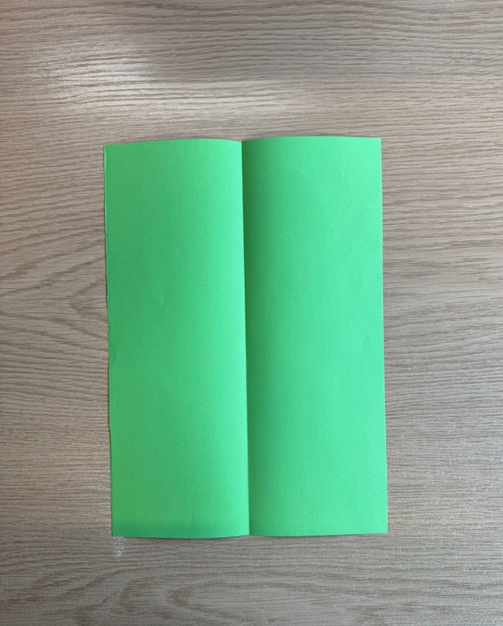
Fold a piece of A4 paper in half to create a crease down the middle.
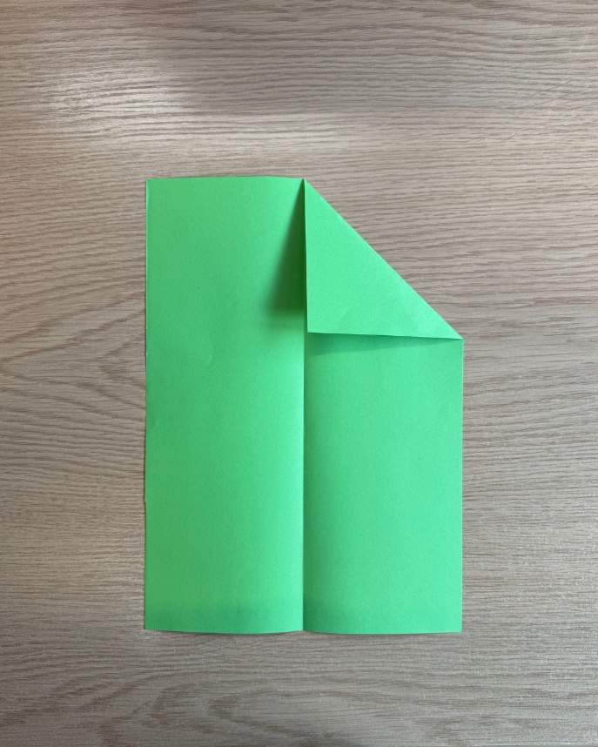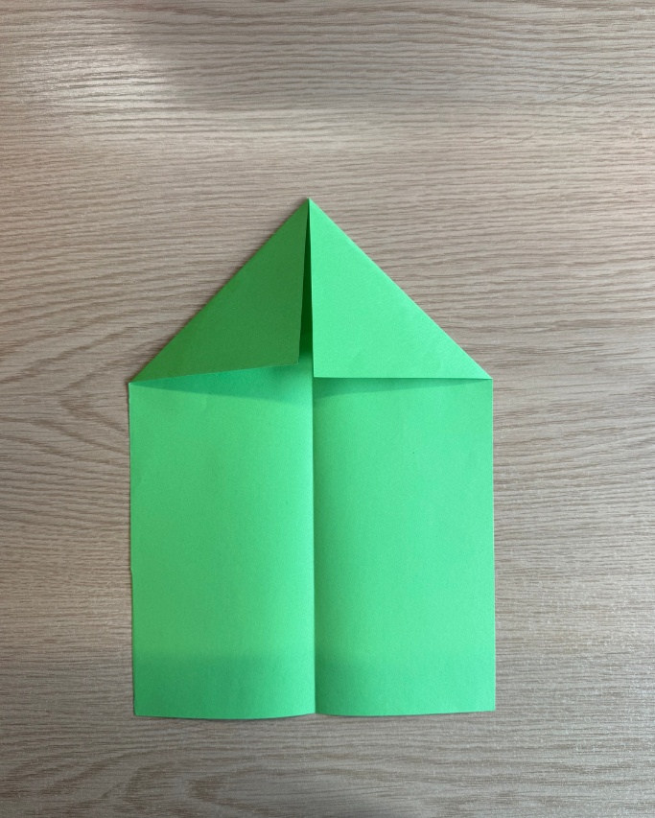
Fold the top corners down towards you until they touch the centre crease. They should form a triangle shape. Try and make sure the corners match up!
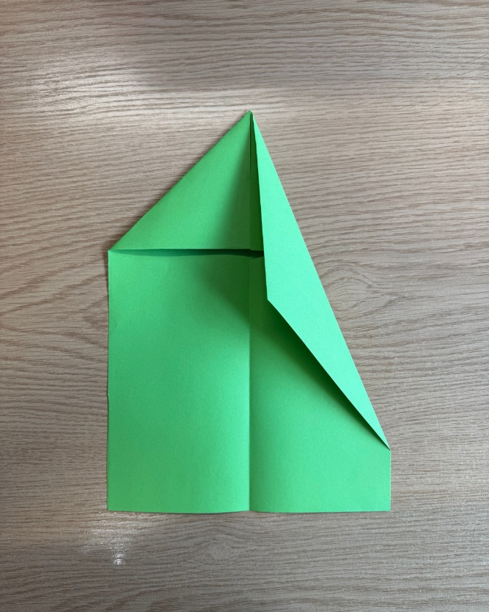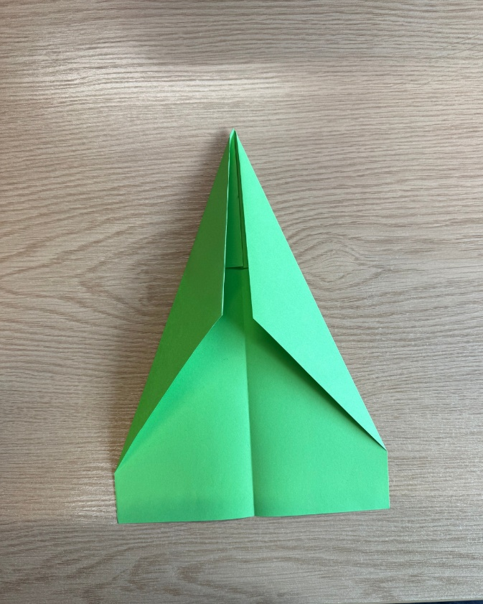
Grab the new top corners of each triangle and fold them towards the centre crease again. This should create an even pointier triangle shape.
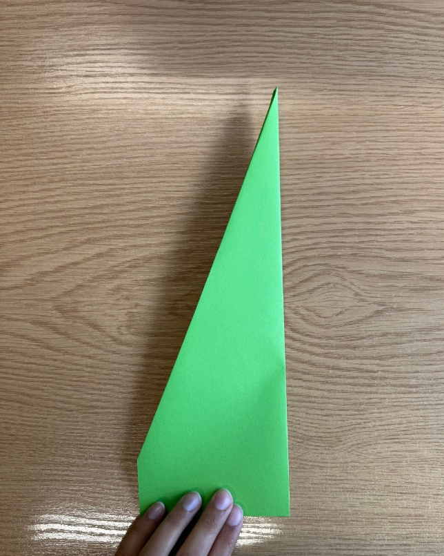
Fold the paper in half along the crease in the middle. You want the folds we’ve created to be on the inside, so the outside is smooth.
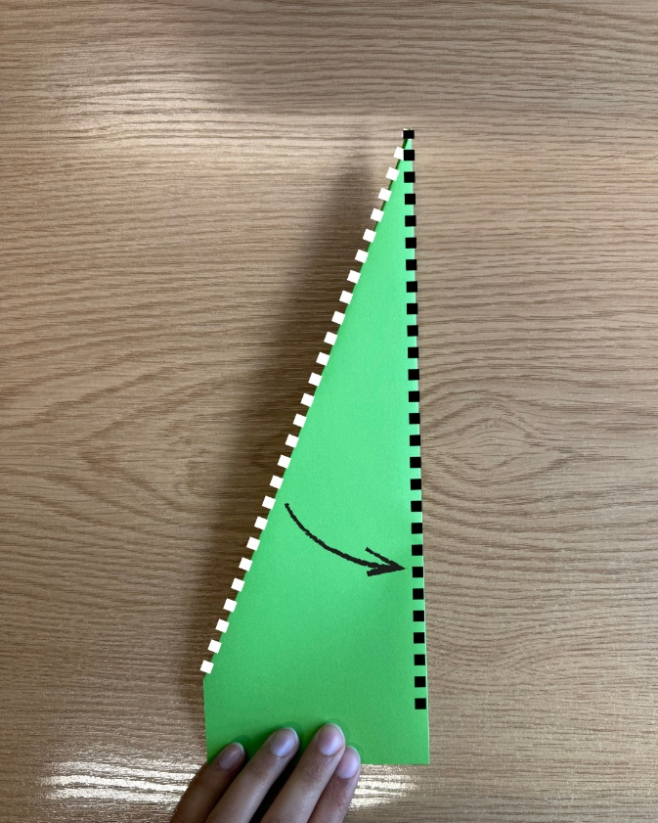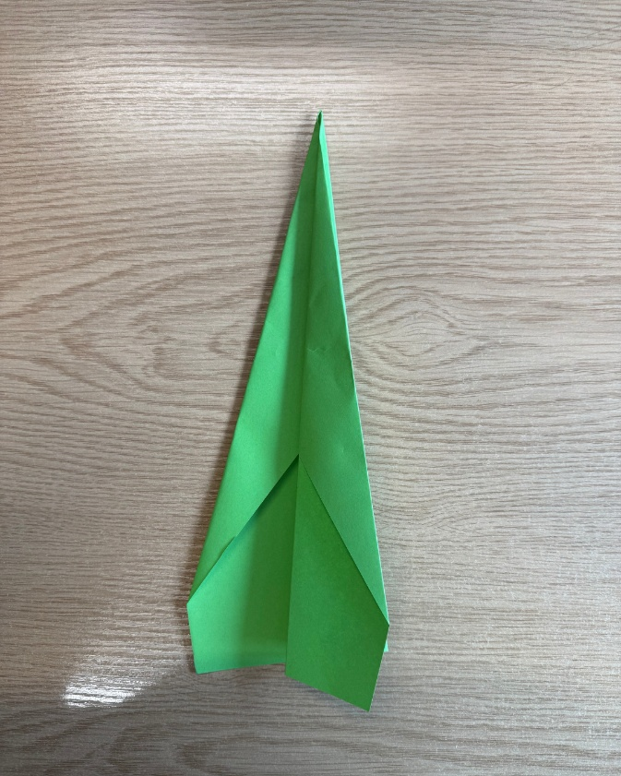
Now for the wings! Fold the angled side of the paper to the crease in the middle, and then repeat on the other side.
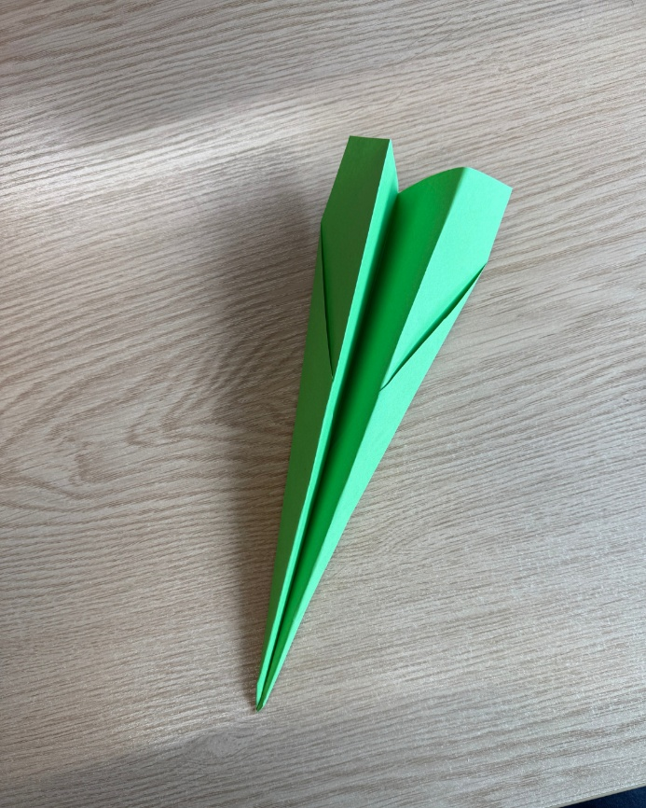
You now have a paper aeroplane. Well done!

