The Fly Zone (Soaring Journeys) instructions
Create a bird puppet and explore movement, journeys and storytelling
Inspired by artist Richard Long
About the artist:
Richard Long makes art by walking through landscapes. He leaves paths, lines and traces behind him.
In this activity, pupils explore their own journeys using colour, texture, symbols and movement.
What pupils will do:
- Collage a bird puppet using pre-cut paper feathers (paper, maps, cellophane, acetate, textured papers) words and symbols
- Use the bird as a movement tool for following, leading and storytelling
- Explore ideas of journeys, different perspectives, change and connection

What you need:
Pre-cut bird puppets or large pieces of card | Symbol prompt sheet / word cards (verbs)
Pre-cut feathers (paper, maps, cellophane  acetate, tracing paper, textured papers) | Pens and markers  Scissors (if cutting)
Glue sticks | Gems and stickers (optional)

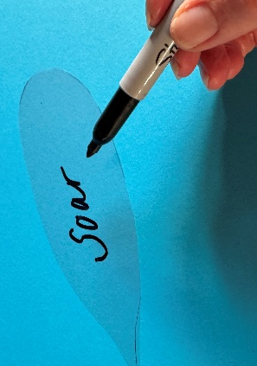
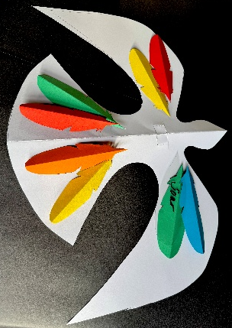
Step-by-step instructions
1. Choose your bird
-Lay it out flat on the table

2. Add feathers
-Choose feathers
-Glue them onto the wings or body
-Each feather can represent a:
place · memory · feeling · part of a journey

3. Add words (optional)
-Choose a word or write your own to describe how your bird moves or feels
-Write on tracing paper or acetate/cellophane feathers if you like

.

4. Add symbols underneath your bird

-Draw, trace or collage simple shapes or symbols
-These symbols can show ideas or feelings from your journey
-Use widgets and communication aids if needed, to support young people in choosing and expressing ideas

.

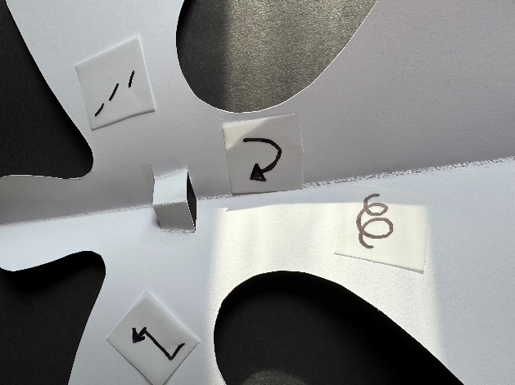

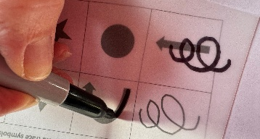

Use the ideas below only as inspiration:
Shape | Shape | Possible meaning | Movement ideas
Spiral |  | Growth, change | Turning, unfolding
Arrow |  | Direction | Forward, reaching
Wave |  | Emotion, rhythm | Swooping, rising, falling
Circle |  | Connection | Returning, revisiting
Triangle |  | Strength | Stability, togetherness
Star |  | Hope, energy | Spark, shine
Path/Line |  | Journey | Walking, exploring
Zigzag |  | Change, challenge | Change direction
Cloud |  | Thinking, wondering | Floating, gliding
Heart |  | Care, belonging | Holding, sharing
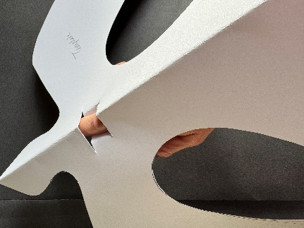
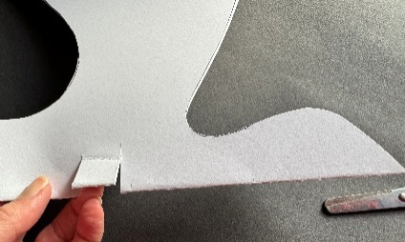
5. Let your bird fly!

- Cut two small slots between the head and body of the bird. Push your finger through the slots so the bird can perch on your finger.

-Move through the space transforming them into a tool for physical expression

-Try different movements: glide, dip, turn, soar etc.

Group movement (optional extension)
Flocking and journeys
- In pairs:
One leads, one follows, swap roles
- As a group:
Move together like a flock
Change speed, direction or mood

Movement prompts:
- Show your bird exploring a new place
- How does your bird move when it’s calm? Excited?

Extra creative option
- Photograph or film the shadows of the bird puppets on walls
- This echoes Richard Long’s idea of leaving traces through movement

