Verb ideas:
fly | soar | rest | dip
turn | rise | drift | glide
hover | perch | swoop | trace
follow | explore | twist | pause

Print, photocopy and cut. Alternatively, pupils could trace symbols and/or design their own:

Bird template: Top tip: Fold your piece of card in half. Place the template along the fold and draw around it (half a bird). Cut it out, then open it up - ta-dah! - you’ll have a perfectly even bird.
Onefold, one cut, beautiful bird!
Try enlarging this template on the photocopier as much as you like, but make sure your paper is double the width of the template so the whole bird fits when opened.

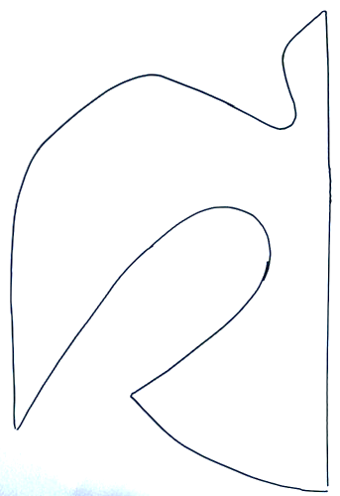

Feather template: Fold your piece of paper or card in half. Place the feather template along the fold and draw around it. Cut it out to create a symmetrical feather.
You can usually get 4- 5 feathers from one sheet of A4.

