Event Risk Assessment Form

Risk Assessment Guidelines

To help ensure the safety of all project participants, A New Direction requires Risk Assessments to be carried out. For more information on relevant legislation, please request a copy of A New Direction’s Health and Safety policy.

Assessment means:
Assessing the risk of a hazard to an employees’ health and safety which may occur in carrying out any work activity and identifying the actions necessary to either entirely remove the risk of that hazard occurring or to minimise it.

A Hazard means:
A potential danger or source of harm to persons.

Likelihood is a measure or estimate of the probability of an event occurring.

The Objective of risk assessment is to ensure that those actions necessary to minimise or remove entirely any risk to an employee's health or safety in carrying out activities are identified and taken.

Priority of Assessment
As all work activities need to be assessed a list of priorities may be necessary to determine the order in which assessments may be carried out. In constructing such a list regard may be had to the degree of potential harm which may be caused by a particular hazard and the number of persons which can be exposed to that risk.

Carrying out a Risk Assessment
1. Identify the Hazards which;
- Are related to any particular work operation
- Classify the degree of Harm which could be caused by the Hazards on a scale between 1 - 5.

The following table may be used for this purpose. The table takes account of the degree of Harm which could occur due hazards:

Harm | 1 | 2 |  | 3 |  | 4 |  |  | 5
 | Slight /  Superficial |  | Moderate |  | Severe |  | Permanent
 | FULL RECOVERY EXPECTED |  |  |  | FATAL /
 | Minimum  Disruption  To Normal  Activities | Return  To Normal  Activities  Expected  within Days |  | Return to Normal Activities Expected within Weeks |  | Return To  Normal Activities  Expected to be Protracted |  | PERMANENT  DISABILITY

2. Estimate the Likelihood of the degree of harm occurring, again on a scale between 1-5.

Likelihood | 1 | 2 | 3 | 4 | 5
 | Extremely Unlikely | Unlikely | Likely | Very Likely | Extremely  Likely

3. Quantify the risks

Risk = Harm X Likelihood

Example: If the most serious Harm = 5

and the Likelihood of it occurring= 5

then the Risk (5 x 5) = 25

This number represents the highest or maximum risk factor for each hazard identified in the work activity.

The resulting risks can be expressed as follows: -

Risk | 1 - 5 - 10 - 15 - 20 - 25
 | Very Low | Low | Moderate | High | Very High

The actions which can be taken may take the form of: -
- Immediate cessation of an activity if the risk is very high and no safe alternative is available
- The introduction of safe working procedures
- Training in safe working procedures
- Changing the material or chemical used or the procedure for its use
- The use of protective clothing
- Provide guarding

This list is not exhaustive and any further guidance required can be sort after by the Facilities and Resources Manager, or your line manager.

- Follow up work
Once actions are identified it is the Facilities and Resources Manager and line management’s duty to ensure their implementation and the monitoring of their continued effectiveness.

Any changes in a work activity will require a review of the assessment.

Regulations require that a record of risk assessments should be made. The attached form can be used for this purpose.

Event Risk Assessment Form

Event Name: | I Am Festival 2026: Journeys | Date and Time: | Wednesday 11th – Friday 13th March 2026 | Venue and Rooms: | Tate Modern  - Clore Studio  - McAulay Studio  - School Lunch Room  - McAulay Seminar Room  - Tanks Studio  - Schools welcome desk foyer space  - Turbine Hall  - Bridge  - Level 5 (only used during Cultural Sector event) | Lead Contact and Staff Present: | Wednesday 11th March  Lynne Brackley  Ross Hunter  Ellene Mash  Corinne M  Jen Cheema  Rebecca Branch  Tyronne Blackwood  Mariah Dechavez  Fala Buggy  Zarah Ahmed  Cultural Ambassador staff  Jo Paul  Phylly Hickish  Jake Watson  Bianca Clarke  Kate Jackson
Thursday 12th March

Rebecca Branch
Lynne Brackley
Ross Hunter
Ellene Mash
Corinne Micallef
Jen Cheema
Zarah Ahmed

Cultural Ambassador staff
Kate Jackson (AFK)
Bianca Clarke (AFK)
Jake Watson (AFK)
Jo Paul
Phyllida Hickish

Friday 13th March

Lynne Brackley
Ross Hunter
Ellene Mash
Corinne M
Rebecca Branch
Yasmin Downie
Tyronne Blackwood
Mariah Dechavez
Zarah Ahmed

Cultural Ambassador staff
Kate Jackson (AFK)
Bianca Clarke (AFK)
Jake Watson (AFK)
Jo Paul
Phyllida Hickish

DETAILS OF EVENT
A range of artistic activities taking place across Tate Modern for Deaf, disabled and neurodivergent children and young people. This includes making workshops, simple puppetry making and promenade movement, dances and light and sensory play. Activities will be delivered by artists and teachers.
Number of people:
- Wednesday 11th March
  - 10:30am – 12pm (approx 55 students & 27support staff)
  - 12:30pm – 2pm (approx 55 students & 26 support staff)
  - All day 5 Cultural Ambassadors

- Thursday 12th March
  - 10:30am – 12pm (approx 38 students & 20 support staff)
  - 12:30pm – 2pm (approx 48 students & 20 support staff)
  - All day 8 Cultural Ambassadors

- Friday 13th March
  - 10:30am – 12pm (approx 50 students & 20 support staff)
  - 12:30pm – 2pm (approx 30 students & 15 support staff)
  - All day 5 Cultural Ambassadors

Who are they:
- Deaf, disabled and neurodivergent children and young people from educational settings aged between 5 – 25, plus support staff and teachers.
- Deaf, disabled and neurodivergent young people taking part in an A New Direction programme – Cultural Ambassadors. Supported by AFK staff
What activities (tech/equipment needed/loud/messy):
- Wednesday 11th March
  - Voot Collective Mini-mob: Cutting and sticking fabric/material to small cardboard cases; using hand drums and percussion and flag on telescopic pole to lead procession across Turbine Hall held by Voot Collective facilitators.
  - Birds Puppetry workshop and procession:

- Thursday 12th March
  - Voot Collective Mini-mob: Cutting and sticking fabric/material to small cardboard cases; using hand drums and percussion to lead procession across Turbine Hall.

- Friday 13th March
  - Voot Collective’s ‘The Way’ Flash Mob (approx. 5 mins): PA speaker set up; live hand drums; net vine held on telescopic poles held by facilitator staff; participants promenade in gallery with various large pieces of fabric.

How long (set-up/duration/clean down):
- Set up
  - Monday 9th March – 10:00am – 5:00pm
  - Tuesday 10th March – 10:00pm – 5:00pm

- Activity
  - Wednesday 11th Marc
    - Briefing: 9:30am – 10:15am
    - Session 1: 10:30am – 12:00pm
    - Session 2: 12:30pm – 2:00pm
    - * NB there is a Cultural Sector Best Practice Network meeting 2:00 – 5:00. Separate risk assessment to be written.

- Thursday 12th March
- Briefing: 9:30am – 10:15am
- Session 1: 10:30am – 12:00pm
- Session 2: 12:30pm – 2:00pm

- Friday 13th March
    - Briefing: 9:30am – 10:15am
    - Session 1: 10:30am – 12:00pm
    - Session 2: 12:30pm – 2:00pm

- Pack down:
  - Friday 21st March 2:00pm – 5:00pm

Food/Dietary:
- Schools – no food to be provided by A New Direction.
- Cultural Ambassadors and AND staff – light refreshments will be provided for the staff team (no nuts to be provided, though no allergies present in group).

Potential complications (extra staff needed/carers/access support):
- Wheelchair and large mobility aid users in space so need to abide by Tate’s capacities and emergency evacuation procedures. There is no given maximum on Level 0, Level 1 has been approved to have a no-limit maximum with step-free access through the Blavatnik exit.
- Need to cater for a variety of access needs
- Some children will need access to Changing Places toilet
- Some children will need access to a private area for feeding
- Busy space with lots of activity and people – quieter spaces for respite will be necessary
- Some spaces are within public areas – interactions with public visitors will need to be monitored, for example regarding photography

How many rooms needed (overspill potential?)
8 spaces have been identified for school activity;
- Clore Studio
- McAulay Studio
- School Lunch Room
- McAulay Seminar Room
- Tanks Studio
- Schools welcome desk foyer space
- Turbine Hall
- Bridge
Some school groups will visit wider gallery spaces
Extra prep/clean down time

Activity /  Area of Concern  ie: what is taking place as part of the event? | Hazards Identified  ie: what can cause harm? | Persons at Risk  ie: who could be harmed by the hazard? | Calculation of existing risk (Harm X Likelihood = Risk) |  |  | Actions to be Taken to Minimize each Risk  ie: what action can you take to lower the level of risk | Risk Acceptable (Y/N?)
 |  |  | Harm | Likelihood | Risk
Emergency evacuation procedure | Fire;  Terrorist attack;  Storm | Staff, visitors, contractors | 3 | 2 | 6 | - Following Tate Modern’s Emergency Evacuation Procedures  - Ensuring exits are kept clear  - Keeping within capacities of the space  - Every member of AND staff to have fully charged phone in case of emergency | Y
Emergency evacuation procedure for wheelchair users | Fire;  Terrorist attack;  Storm | Wheelchair users, children and young people with SEND | 4 | 2 | 8 | - Refuge areas clearly signposted  - Only have the maximum number of wheelchair users in the space at any one time  - Following Tate Modern’s Emergency Evacuation Procedures  - Children and young people supported by staff from their school throughout their visit  - Every member of AND staff to have fully charged phone in case of emergency  - Tate to give a briefing to staff and facilitators on evacuation procedure, emergency exits, fire marshals & first aiders at the start of the day. | Y
First Aid | Minor injuries – insect bites, heat stroke, vomiting, general accidents. | Staff, visitors, contractors | 2 | 3 | 6 | - Tate to lead on First Aid. All Tate security staff first aid trained and can be summoned via radio by Tate staff as per Tate’s protocols.  - Additionally, Ross Hunter from A New Direction has been given basic First Aid training and can administer first aid in an emergency where Tate staff are not available.  - All students supported by staff from their school  - Every member of AND staff to have fully charged phone in case of emergency  - 11 Tate stewards positioned throughout all festival spaces with radios to security in the event of unwell child. | Y
Care of children | Lost children | Children and young people | 3 | 3 | 9 | - I Am staff clearly visible in pink I Am T-shirts  - Front desk at the ground level of Blavatnik Building used as a muster point  - All children and young people to be supervised by school staff throughout their visit  - Every member of AND staff to have fully charged phone to communicate if there is a lost child  - Tate team informed immediately if a child goes missing  - Visual story shared with school staff ahead of event to support learners to visualise the space.  - All internal Tate staff briefed ahead of festival regarding event timings and inclusive approaches to SEND school students in public spaces across festival.  Cultural Ambassadors:  - AFK staff have contact details of all participants as well as emergency contacts.  - Participants given clear instructions for what time they need to arrive for the session and/or return from lunch. | Y
Toilet provision | Access needs | Staff, visitors, contractors | 2 | 3 | 6 | - Changing places toilet available in the Tate  - All toileting needs administered in toilets and changing places. No A New Direction, AFK, Cultural Ambassadors or Tate teams are involved in intimate care  - School told with as much advance notice as possible in changing places toilet are out of action for any reason | Y
Risk of fire | Burn or smoke injuries | Members of the public especially people with disabilities and children /  staff /  event participants /  contractors | 2 | 2 | 4 | -Tate to lead on fire safety, including evacuation, as per their Fire Safety Policy  - 11 Tate stewards positioned throughout all festival spaces are briefed regularly on building evacuation procedures, and are responsible for supporting evacuation of all participants.  - Fire evacuation procedures explained to all staff on the morning of each delivery day, including all school liaison staff.  - Tate to ensure that adequate fire prevention methods are in place as per their Fire Risk Assessment- | Y
Litter | Litter or other debris generated by event | (Complaints from) Members of the public or Tate team | 1 | 2 | 2 | - Ensure that adequate time is given for clear up at the end of event  - Not using any materials within the space not permitted by Tate Modern | Y
Working with children and young people | Molestation / abduction | Children | 4 | 2 | 8 | - Children to be supervised at all times by school support staff  - All contractors undergo DBS check  - Appropriate number of staff supporting space  - Level 05 space closed off to public  - No member of AND staff, contractor or Cultural Ambassador to be left alone with a student | Y
Working with children and young people | Absconding | Children | 3 | 4 | 12 | - Students are accompanied by school staff at all times  - Tate door staff briefed to remain vigilant of young people exiting on their own | Y
Working with children and young people | Biting | Staff and workshop leaders | 3 | 2 | 6 | - Staff made aware of risk of biting for students  - Students are supervised at all times  - Tate to lead on First Aid. All Tate security staff first aid trained and can be summoned via radio by Tate staff as per Tate’s protocols.  - Additionally, Ross Hunter from A New Direction has been given basic First Aid training and can administer first aid in an emergency where Tate staff are not available. | Y
Working with children and young people | Safeguarding concern | Children | 4 | 2 | 8 | - All staff, partners and freelancers working on behalf of AND and Tate have enhanced DBS checks  - All AND staff and freelancers are familiar with AND’s policy and code of conduct  - Daily briefings for staff will remind everyone of reporting procedures  - Rebecca Branch, AND’S DSL present and is responsible for ensuring correct reporting processes are in place  - Tate staff also have clear reporting processes in place and will liaise with Rebecca if needed | Y
Music | Noise pollution | Tate Visitors /  Event attendees / Staff on site | 1 | 3 | 3 | - Ensure full compliance with all Noise/Music conditions of Tate Modern  - Ask activity leaders to turn down music when necessary  - Where possible, put noisier activities in a space that can be shut off from other activities | Y
Use of hoist | Incidents involving hoist | Staff, children | 2 | 2 | 4 | - Only trained school staff allowed to use the hoist and are responsible for ensuring it is correctly set up. | Y
Use of scissors | Cuts, lacerations | Staff, children | 2 | 2 | 4 | - Facilitators to supervise use of scissors at all times.  - Scissors to be counted out and counted in from and kept securely by activity facilitator.  - Expectations around scissor use to be included to all staff in briefing each day.  - All scissors are approved for school use (i.e. not craft scissors). Easy-hold safety scissors available to make cutting activities safer and more accessible.
Movement based activities | Trips, slips and falls | Staff, visitors, contractors | 3 | 2 | 6 | - Space used for movement cleared of objects and trip hazards  - Any spillages cleared up straight away  - Wires cordoned off, or fastened to the floor to avoid tripping | Y
Craft activities | Choking | Staff, visitors and contractors | 3 | 2 | 6 | - Materials monitored by staff  - Tate to lead on First Aid. All Tate security staff first aid trained and can be summoned via radio by Tate staff as per Tate’s protocols.  - Additionally, Ross Hunter from A New Direction has been given basic First Aid training and can administer first aid in an emergency where Tate staff are not available. | Y
Craft activities | Mess, destruction to environment | Staff, visitors and contractors | 1 | 4 | 4 | - Wipes available on craft tables  - Hand washing sinks in space  - All glue sticks to be non-toxic and monitored by activity staff | Y
Electrical items | Shocks | Staff, visitors and contractors | 3 | 2 | 6 | - All items PAT tested  - No open containers of liquid allowed near electrical equipment | Y
Movement/Dance | Over exertion, injuries, dehydration | Staff, participants | 2 | 3 | 6 | - Space cleared of obstacles prior to activity  - Water provided in space  - First Aid kit provided  - Warm-ups completed where appropriate  - School staff aware of any relevant medical issues  Cultural Ambassadors:  - AFK aware any relevant medical issues
Damage to contractor equipment | Reputational damage and financial repercussions | Staff, visitors and contractors | 1 | 2 | 2 | - Students monitored by school staff at all times  - Numbers of students on each activity limited | Y
Lots of people in space | Overwhelm | Staff, visitors and contractors | 2 | 4 | 8 | - Quieter spaces available  - Other spaces in Tate available if complete removal from space needed  - Ear defenders will be provided | Y
Fall from height | Injury, death | Visitors | 5 | 1 | 5 | - School staff told in advance and instructed to complete their own risk assessment on behalf of their group.  - Tate FOH staff member to always be present on the bridge during activity.  - Barriers on bridge
Emotional Harm (e.g. needs not addressed, conflict between individuals, bullying) - Cultural Ambassadors | Stress, withdrawal from sessions | Participants | 3 | 3 | 9 | - Access Rider/ equivalent activities completed at start of programme to gain a better idea of how best to support participants.  - Breakout space available  - Conflict addressed sensitively by staff  - Sufficient staff in space to be able to support individuals  - Strong communication between AFK and AND to manage any situations that arise  - Participants made aware of expected behaviour in sessions and reminded to treat other respectfully. | Y

This Risk Assessment needs to be completed and shared with both Felix Yoosefinejad, Facilities and Resources Manager and a Director for approval.
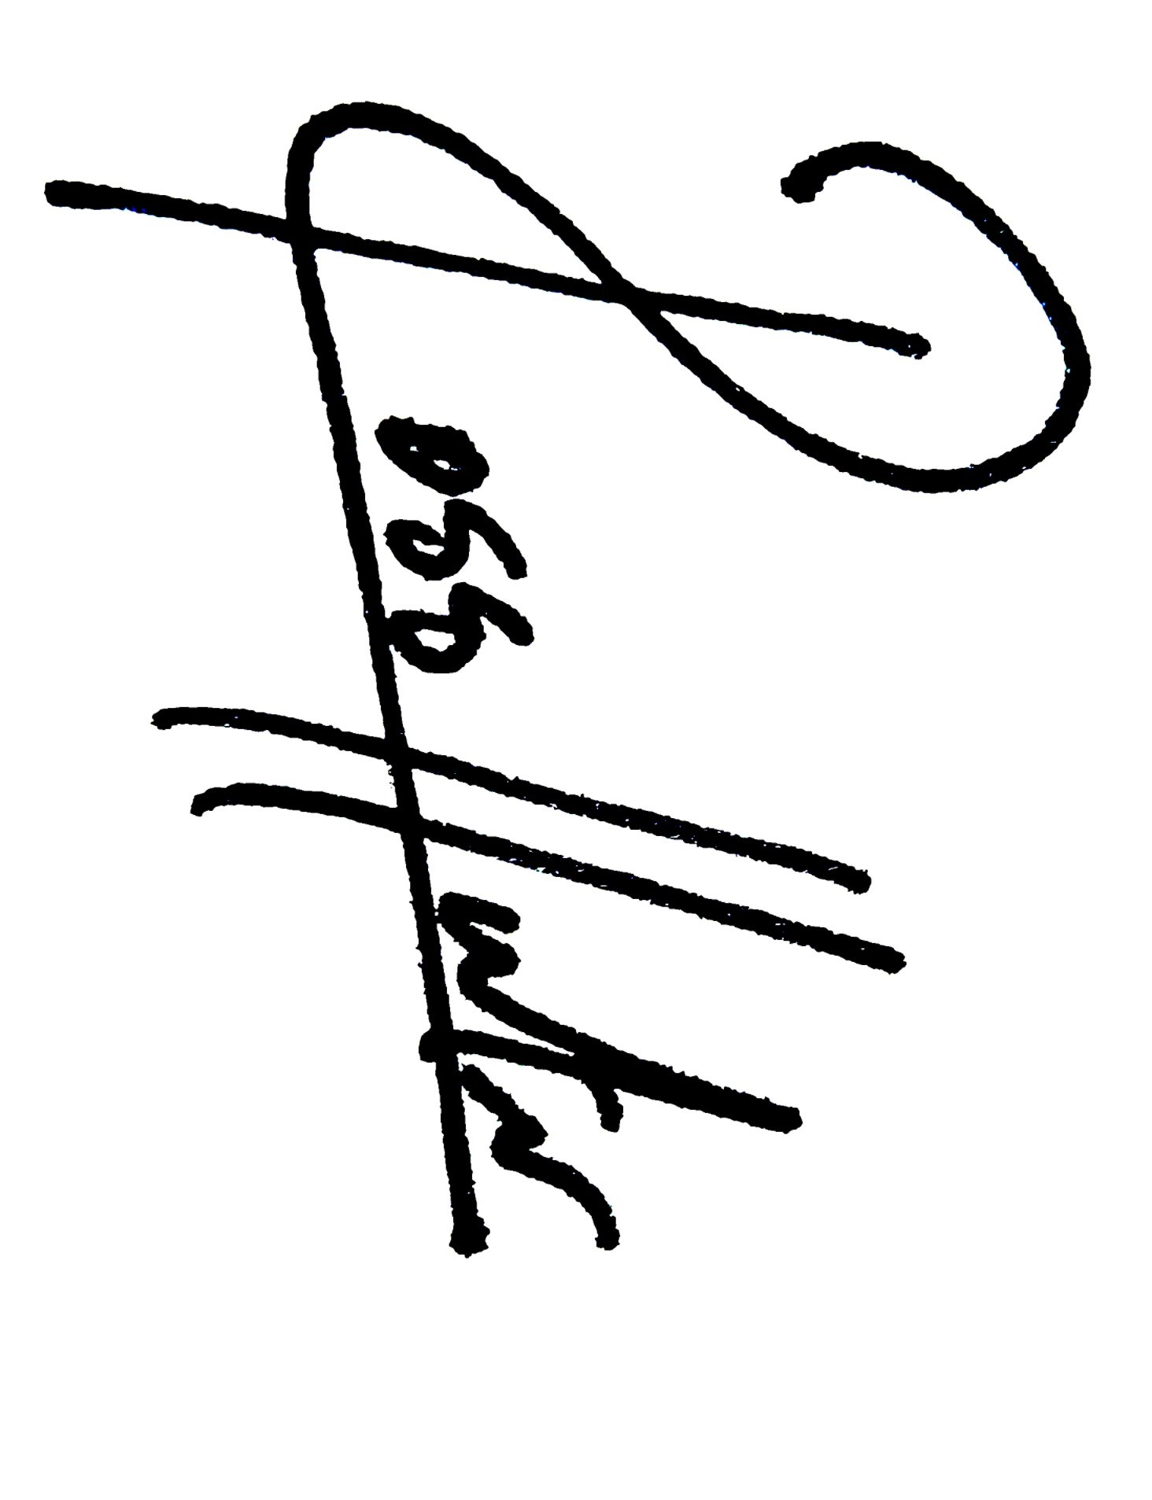
Name/Signature of person completing Risk Assessment: Ross Hunter, Programmes Manager, Education and Culture:

Date: 26/2/26

Signature of approval – Felix Yoosefinejad, Facilities and Resources Manager:
Date: 25/2/26

Name and Signature of approval – Rebecca Branch, Director of Education and Culture:
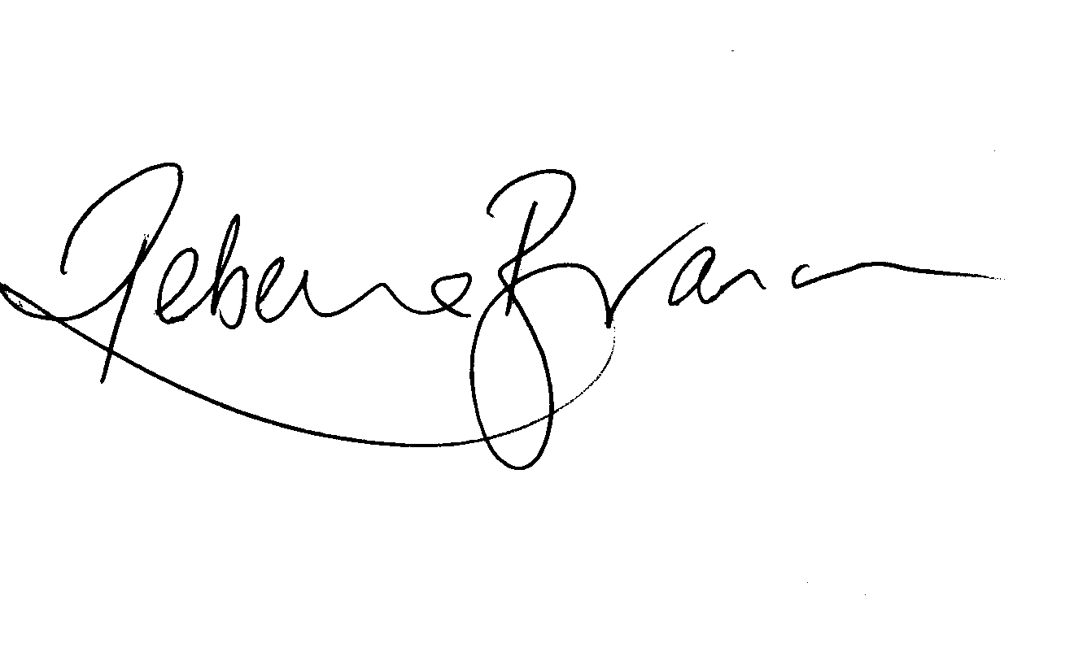
Date: 26/2/26

Risk Assessment Date Approved: 26/2/26

