

I Am Festival 2026 – Visual Story

If you want to edit this into your own visual story guide for your learners, you can cut/copy/paste the images and text from here.

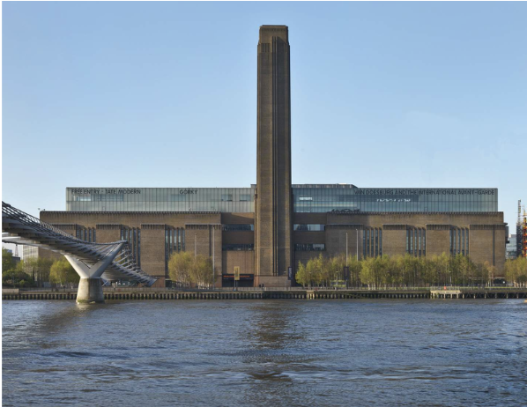 | This is Tate Modern, a large building next to the River Thames
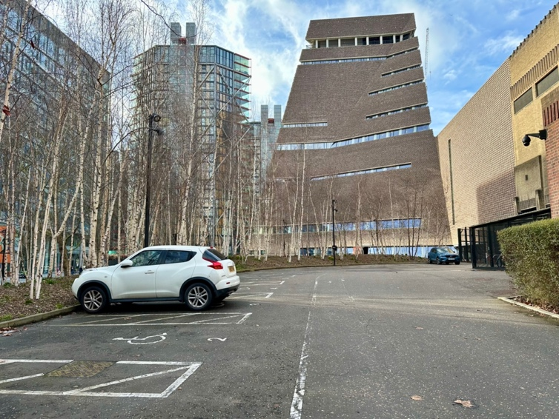 | If you are travelling to the I Am Festival in a minibus, you will park in the Tate car park
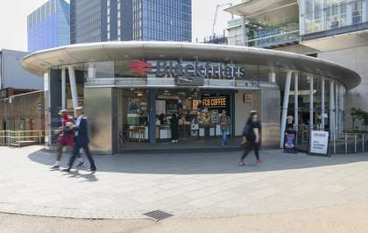 | Or you might travel on the train or by bus to the Tate Modern
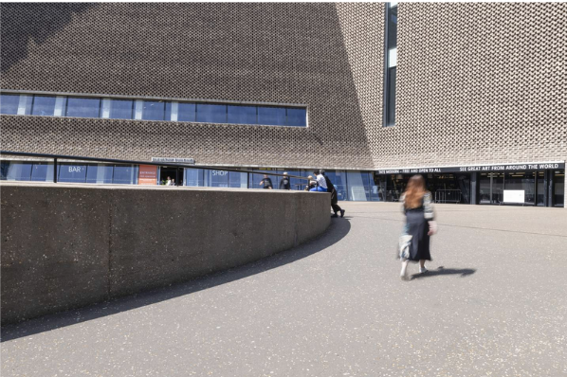 | This is the entrance to the Blavatnik Building at Tate Modern.  You can follow the curved wall up a sloped path to the automatic doors.
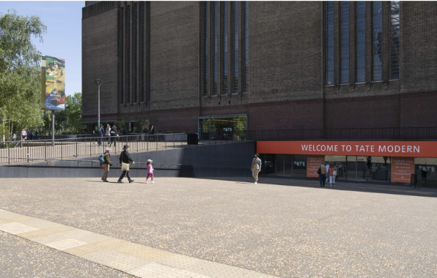 | This is the entrance to the Natalie Bell Building at Tate Modern.  The entrance is on a downhill slope and there are automatic doors.
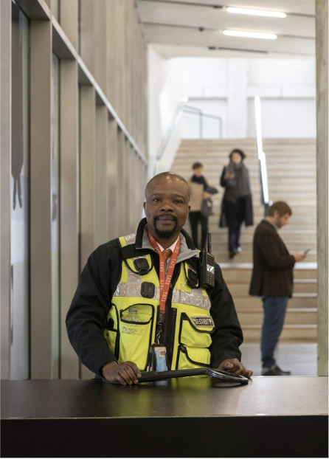 | A security person will be there to greet you on the door.  They are there to keep us safe.
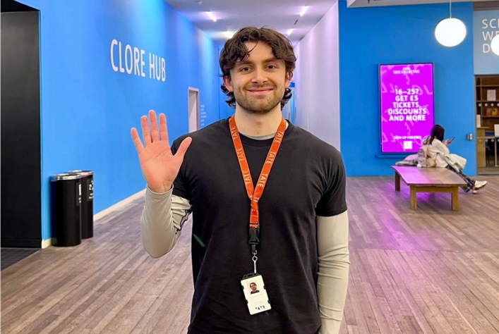 | You will meet staff from Tate Modern who can show you where to go.  They wear black clothes and an orange lanyard like this person.
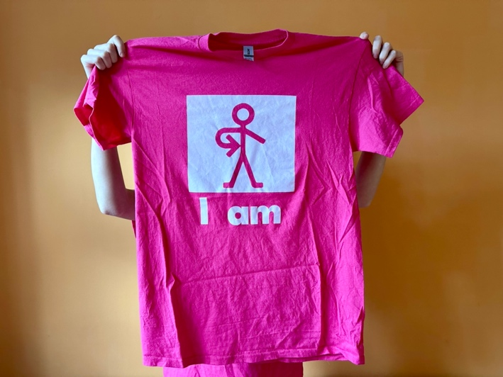 | You will also meet some of the team from A New Direction.  They wear pink T-shirts like this.
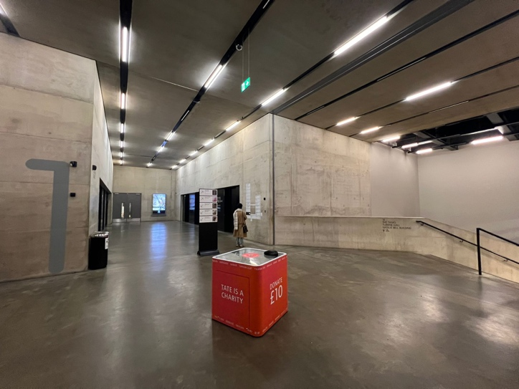 | You will use the lift or stairs to go to Level 0, where there will be lots of activity.  There are 8 lifts.
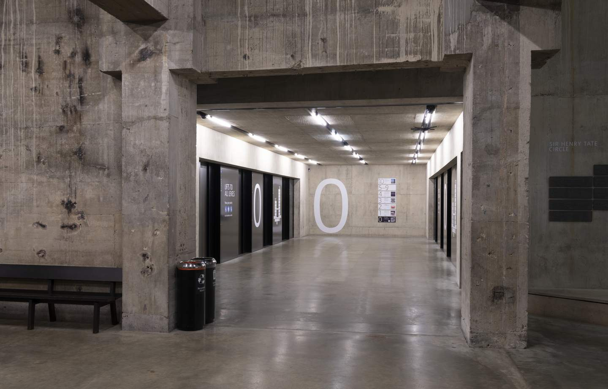 | You will walk down the stairs or exit the lift on Level 0 and walk through the Tanks foyer
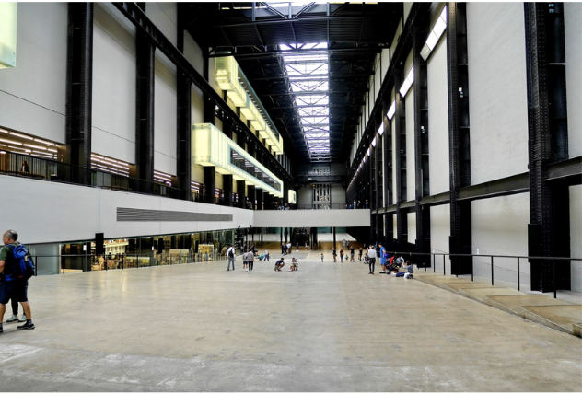 | You will walk through the Turbine Hall.
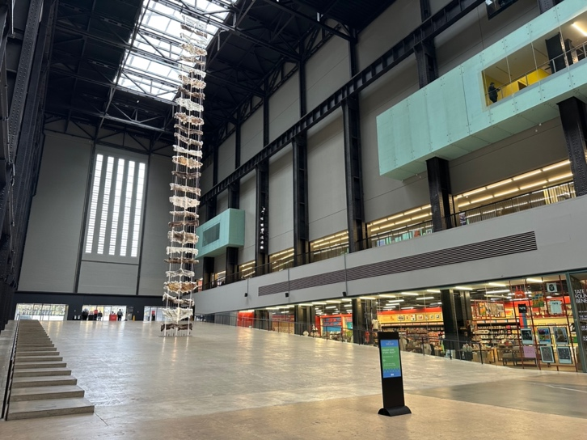 | It is a big and open space.
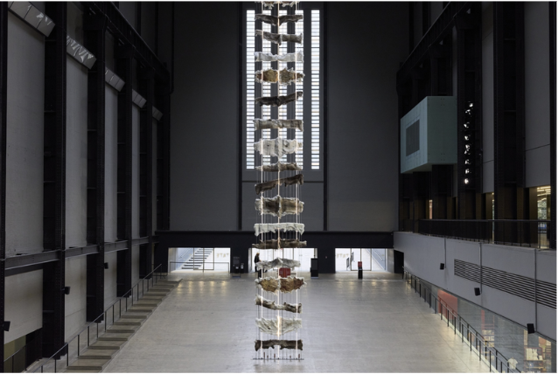 | You will hear some sounds like animal noises and sounds of voices that are low and rumbly and sometimes loud.
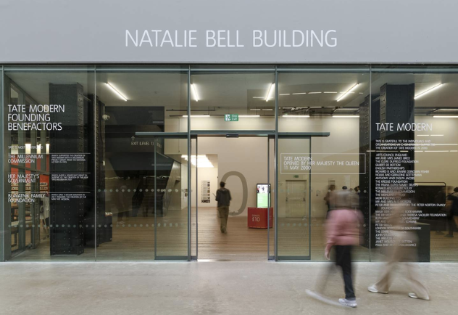 | This is the door to the activity space on Level 0, the Clore corridor.  It has automatic doors that open
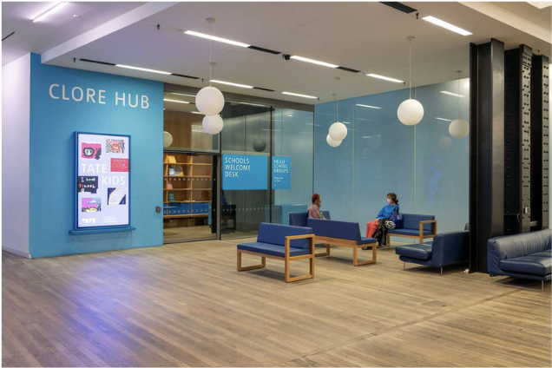 | This is the activity space.  There may be a lot of people doing the activities.
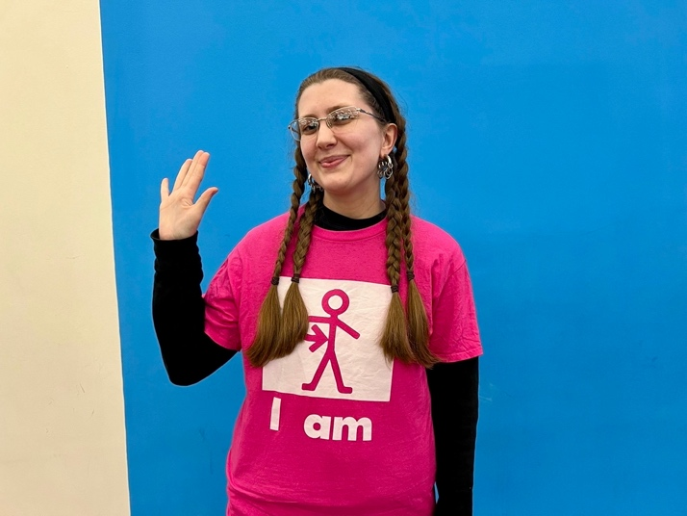 | You can ask a staff member (in a pink T-shirt) if you need a quiet space or anything else such as ear defenders or the way to the toilets.
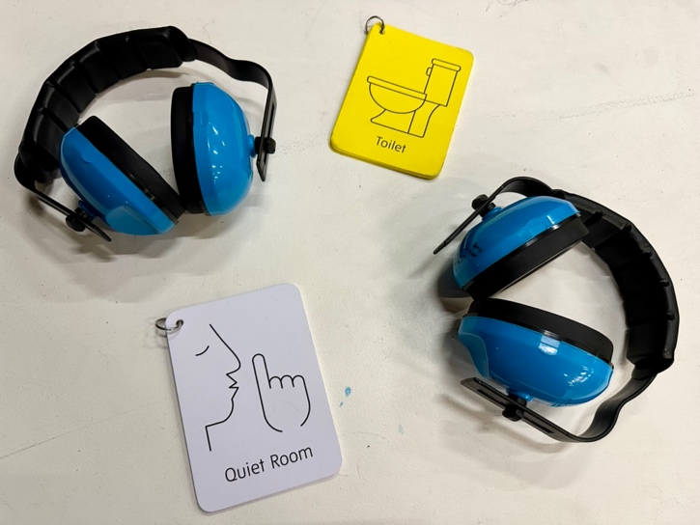 | We have ear defenders that you can use if it’s noisy.  And a quiet room you can go to if you want a break from the festival activities.
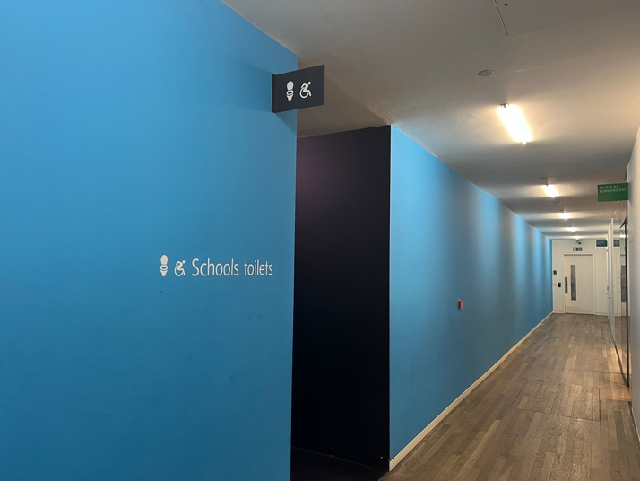 | These are the toilets.
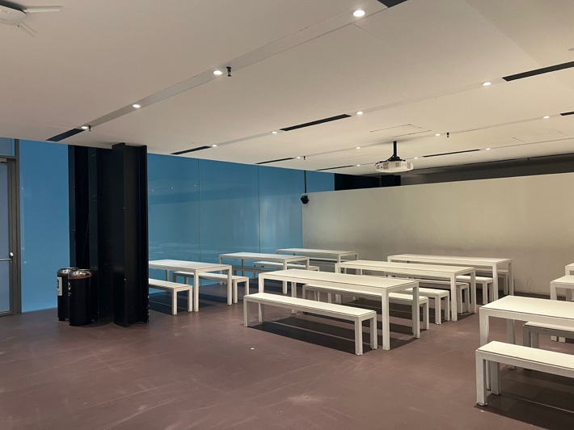 | You can have lunch in the Macaulay Lunchroom.  The lunchroom looks like this.
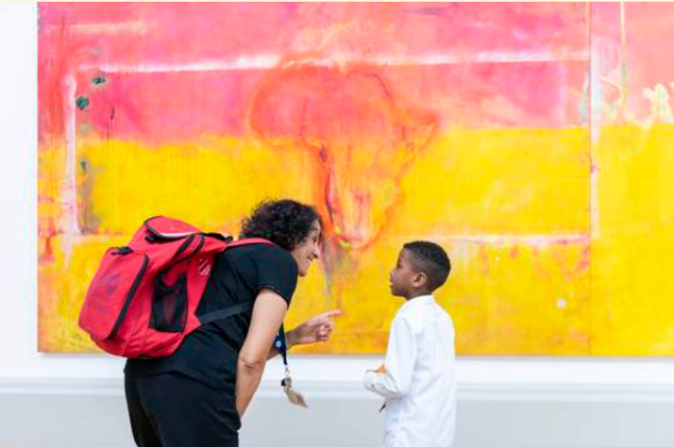 | You can visit the galleries to see paintings and sculptures.

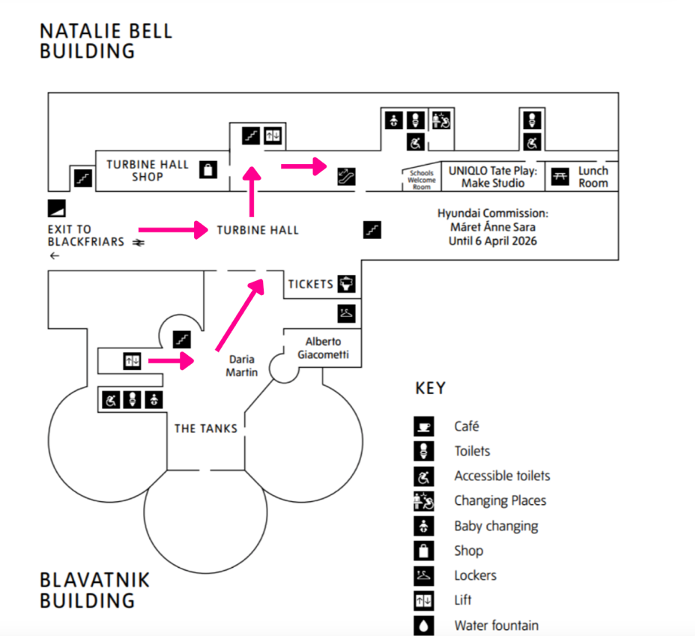

For more information about access, including Changes Places toilet and other facilities/resources, you can visit this website: Tate Modern Visual Story
Download the Tate Modern Map
You can access a 3D virtual tour of the Tate Modern building here.

Artworks Curated by the Cultural Ambassadors:

- Monster Chetwynd, A Tax Haven Run by Women (Blavatnik Level 3, Performer and Participant, Room 7)
- Cildo Meireles, Babel (Natalie Bell Level 4, Media and Networks, Room 6)
- Meschac Gaba, Art and Religion Room (Natalie Bell Level 4, Materials and Objects, Room 9)
- Rudolf Stingel, Untitled (Natalie Bell Level 4, Materials and Objects, Room 6)
- Máret Ánne Sara, Goavve-Geabbil (Turbine Hall)
- Richard Long, Artist Rooms (Blavatnik Level 4, Artist Rooms)

If you have any questions about access, please email us: iam@anewdirection.org.uk

